**A.I BASED AND CONTROLLED SMART AGRICULTURE FIELD**A thesis submitted  
ByHUSSAIN SALEEM (13079).  
MUHAMMAD HAMZA (12626).  
MUHAMMAD OSAMA (13088).  
SYED TAHIR ABBAS HAIDER NAQVI (12868).  
To  
Department of Computer Sciences   
In partial fulfillment of  
The requirement for the  
Degree of  
**BACHELORS OF SCIENCE IN COMPUTER SCIENCES**  
In  
(Image Recognition, A.I, Web Development and Data Sciences)  
This thesis has been

Accepted by the faculty

**FACULTY OF COMPUTER SCIENCES**

Dr. Muhammad Zulqarnain Siddiqui  
Supervisor

# Acknowledgement

We would like to express my sincere gratitude to several individuals and organizations for supporting us throughout our Graduate study. First, we wish to express our sincere gratitude to my supervisor, Dr. Muhammad Zulqarnain Siddiqui, for his enthusiasm, patience, insightful comments, helpful information, practical advice, and unceasing ideas that have helped me tremendously at all times in my research and writing of this thesis. His immense knowledge, profound experience, and professional expertise in Electronics have enabled us to complete this research successfully. Without his support and guidance, this project would not have been possible. We could not have imagined having a better supervisor in my study. We also wish to express our sincere thanks to IQRA University for accepting us into the graduate program. This financial support has enabled me to complete our bachelor’s studies successfully. Finally, last but by no means least; also, to everyone in the Computer Sciences department, it was great sharing premises with all of you during the last four years. Thanks for all your encouragement!

**Table Of Content**

**Chapter 1: Introduction**

1.1 Problem Statement…………………………………………………………………….….....7

1.2 Project Scope……………………………………………………………….…….……..…...8

1.3 Features……………………...…………..............................................................................10

1.4 Technology ………………………………………………..........………………….......12-34

**Chapter 2: Literature Review** …….…………………….……………………..…….…..36-52

**Chapter 3: Research Methodology**

3.1 Architectural Diagram………………………..………………………….………,…..…....55

3.2 Use Case Diagram……………………………………………………….…………,…......57

3.3 Class/UML Diagram……………………………………….………………………,…......60

3.4 Circuit Diagram……………………………………………………….…….………..…,.….63

3.5 Process Flow Diagram…………………………………………….…….…..……..…,……66

3.6 Implementations………………………………………….…………….……...…............…70

**Chapter 4: Data Analysis**

4.1 Artificial intelligence-based farming …………………………………………….….…….74

4.2 Image Processing on plants ………………………..……………………………….….….75

4.3 Image Processing Algorithms ………………………...………………………….….........77

4.4 Data from sensors …………………………………………………………………..…….84

**Chapter 5: Conclusion and Future work**

Conclusions……………………………………………………….……………………...........87

Future Work ………………………………………….……….………………………..……..87

**Chapter 6: Bibliography…...**…………………………………………….…….................90-92

**List of Figure**

Fig 1.1 Raspberry pi ……………………..………………………………………………….….16

Fig 1.2 Soil Moisture Sensor ………………………………………………..……...……….….17

Fig 1.3 Soil pH Sensor …………………………………………………………….......…….….19

Fig 1.4 Temperature/Humidity Measure DHT11 Sensor …………………..……….….……….20

Fig 1.5 Light Dependent Sensor ……………….…………….……...…………………....….….22

Fig 1.6 Submersible Mini Water Pump ……………………………...……...…….....………….24

Fig 1.7 Pi Camera …………………………………………………………...………...……..….25

Fig 1.8 Four Channel Rely Module ….……………………………………...……………..........27

Fig 1.9 12 Volt Fan …………………….…………………………………………………........28

Fig 1.10 LCD 16x2 …………………………………………………......……………………...30

Fig 1.11 Gas Sensor ……………………..…………………………...………....…………...…31

Fig 1.12 Barometric Pressure Sensor ……..…….…………………...…….………………...…33

Fig 1.13 Analog to Digital MCP3008 ……………………………......………………………...34

Fig 3.1 Use Case Diagram …….………….…………………………………………………....58

Fig 3.2 Class/UML Diagram ……………......…………………………………………....……61

Fig 3.3 Circuit Diagram………………………..…………………………………….…………64

Fig 3.4 Process Flow Diagram …………..………………………………………….…….…....67

Fig 3.5 Circuit Demonstration …..……………………………………………….…………….60

Fig 4.1 Plant’s Types of Diseases …………………………….……………………………….80

Fig 4.2 Confusion Matrix …………………………………..……………………………….….80

Fig 4.3 Diagnose Plant Diseases……………………………………………………………….82

Fig 4.4 Data Sets …………...…………………………………………………….…….………83

Fig 4.5 Project Interface ………………………………………………….……...…….………84

**Abstract**

This abstract presents an overview of an AI-based and controlled smart agriculture field system that uses sensor technology for real-time field monitoring and supports both automated decision-making and human user control. The system makes use of a network of sensors to gather real-time data on a variety of characteristics, including temperature, humidity, soil moisture, and crop health and sends it to the database through which it is shown on the website. With the help of these sensors, the field is continuously monitored, giving users knowledge of the factors influencing crop growth. AI algorithms are used to interpret and analyses the data that has been acquired, giving the system the ability to automatically decide how best to allocate resources like water and pesticides. To deliver timely and accurate treatments, AI algorithms consider elements such as crop water requirements, illness detection, and insect infestations. Users can take an active role in decision-making because of the system's manual user control features. Users have the option to override automated judgements and make human adjustments depending on their knowledge and preferences through a user interface. This feature offers flexibility and gives users the ability to modify the system's operations to suit their own requirements.

# Chapter # 1

**Introduction**

* 1. **Problem Statement:**

To The problems with conventional farming practices have given rise to a viable solution: smart agriculture, powered by artificial intelligence (AI). Artificial intelligence-based smart agriculture has the ability to completely transform the agricultural industry by integrating field monitoring, disease detection, soil and humidity monitoring, and automated application of water and pesticides to crops. However, in order to guarantee the successful deployment and wide-scale uptake of these technologies, a number of important difficulties must be resolved.

First off, one of the major difficulties in AI-based smart agriculture is precise and trustworthy field monitoring. In order to gather real-time data on several characteristics such as temperature, humidity, light intensity, and crop development, sensor networks and drones are being used. There are many technological problems involved in ensuring smooth connectivity, reliable data transfer, and efficient data processing techniques to make sense of the gathered data. Additionally, it is important to carefully assess how these monitoring systems can be scaled up to cover vast agricultural regions and how much it will cost to implement and operate them. Second, a key component of smart agriculture is the early detection of illness in crops. Early disease identification and detection can dramatically reduce crop losses and allow for prompt action. However, it is a challenge to correctly detect and categories diseases based simply on visual symptoms or sensor data. It is extremely difficult to create AI algorithms that can reliably identify and categories a large range of diseases in different crops. Furthermore, for these algorithms to produce accurate illness diagnoses, high-quality training data must be accessible and available. Finally, effective water and pesticide resource management is crucial for sustainable agriculture. In order to optimize irrigation and ensure effective water management, AI-based systems may examine weather patterns, crop water requirements, and soil moisture levels. Similar to this, automated pesticide distribution based on real-time illness and pest monitoring can minimize chemical use and lessen its impact on the environment. However, it is a challenging task that necessitates thorough data analysis and modelling to develop reliable algorithms that can precisely estimate crop water requirements and optimize pesticide application in real-time.

By addressing these issues, AI-based smart agriculture can become more productive, use fewer resources, and adopt sustainable farming methods. The agriculture industry can embrace AI's potential to produce food in a way that is more effective, resilient, and environmentally friendly by addressing technical, data, and operational challenges.

* 1. **Project Scope:**

The project aims to implement smart agricultural techniques and technologies to enhance productivity, efficiency, and sustainability in the agricultural field. It involves the integration of various digital technologies, data analytics, and automation to optimize crop cultivation, livestock management, resource utilization, and decision-making processes. As all of us know that the agriculture is one the most important industry of Pakistan which gives us many benefits and is linked to our country's economy, despite all of that the situation of our farmers is very poor. They don't even have the necessary tools or knowledge to use those tools and they have to work tirelessly to do their work that's why we are making an application that can automate the process of farming by using image recognition through an AI which can save our farmers time and extra effort that they have to put and make the chances of growing good crops higher and the percentage of crops Getting bad lower. The idea of our project is that we can check how or when our crops need water or supplements that it needs on time, this can be figured out by using datasets Air Humidity, Air Temperature, Soil Moisture, Soil pH and Soil Salinity, by using these datasets we can check if there is any disease, pesticides, humidity, temperature of the crops, moisture level of soil, availability of nutrients in soil, toxicities in the soil. Improve crop yield and quality through optimized irrigation, fertilization, and pest management. Enhance livestock monitoring, health management, and productivity.

Minimize resource wastage and environmental impact through efficient use of water, energy, and fertilizers. Enable data-driven decision making for farmers, enabling them to make informed choices and maximize profitability. Facilitate remote monitoring and control of agricultural operations to increase productivity and reduce labor requirements. Promote sustainable farming practices by minimizing the use of chemical inputs and optimizing resource allocation. Sensing and Monitoring Systems: Installation of sensor networks to monitor soil moisture, temperature, and nutrient levels. Implementing weather monitoring stations for real-time weather data collection. Livestock tracking systems for monitoring animal health, behavior, and productivity. Data Analytics and Decision Support: Developing algorithms and models to analyze sensor data and provide actionable insights. Integration of data from multiple sources to generate predictive models for yield forecasting, disease detection, and pest control. Implementing decision support systems for optimized resource allocation and farming practices. Automation and Control Systems: Implementing automated irrigation systems based on soil moisture levels and weather conditions. Deploying smart feeding and milking systems for livestock management. Utilizing drones for crop monitoring, spraying, and aerial surveys. Connectivity and Communication: Establishing a robust network infrastructure for data transmission and communication between devices. Integration of IoT (Internet of Things) technologies for seamless connectivity and data exchange. Enabling remote access and control of agricultural operations through mobile applications and web interfaces.

* 1. **Features:**

It performs Automatic operation of Farming products like windmill, water fall etc. With the help of image recognition, it can detect Diseases in farming products like plants, vegetables and fruits. We can get a complete Information of Bugs and Diseases in our online servers. It displays all information on web pages related to the Field Smart agriculture is an emerging concept, because IOT sensors are capable of providing information about agriculture fields and so touch supported the user input. Smart farming refers to the use of technology and data analysis to optimize and improve agricultural practices. Some examples of smart farming technologies include precision agriculture, which uses sensors and GPS to collect data on soil conditions, crop health, and weather patterns, and then uses that data to optimize irrigation, fertilization, and pest control; and precision livestock farming, which uses sensors and other technologies to monitor the health and welfare of livestock and optimize their feeding, housing, and care. One way that image processing could be used in a smart farming project is for disease detection in crops or livestock. By analyzing images of crops or animals, it may be possible to identify signs of disease or stress, such as changes in color, texture, or shape. This information could be used to take early action to prevent the spread of Disease or to treat affected plants or animals. There are many other ways that image processing could be used in a smart farming project. For example, it could be used to monitor the growth and development of crops, to identify weeds or pests, or to assess the quality of produce. It could also be used in conjunction with other technologies, such as sensors or drones, to provide a more comprehensive view of the farm and its operations.

Farmers can remotely monitor and control various aspects of their farm operations through mobile applications or web interfaces. They can access real-time data on soil moisture, temperature, crop growth, livestock health, and environmental conditions. They can also control irrigation systems, nutrient application, and other farm equipment from a central dashboard. The project incorporates a network of sensors to collect data on soil moisture, temperature, humidity, nutrient levels, and weather conditions. These sensors provide accurate and timely information to farmers, enabling them to make informed decisions about irrigation, fertilization, and pest control. Smart farming techniques optimize water usage by providing irrigation based on the specific needs of crops. Soil moisture sensors and weather data help determine the precise amount of water required, reducing water wastage and improving crop yield. The project includes the use of sensors, drones, or satellite imagery to monitor crop health and detect early signs of diseases, nutrient deficiencies, or pest infestations. This enables timely interventions and targeted treatments, minimizing crop losses and reducing the reliance on chemical inputs. Smart farming involves tracking and monitoring livestock using wearable devices or RFID tags. Farmers can collect data on animal behavior, health parameters, and productivity. This helps in early disease detection, optimizing feed and nutrition, and improving overall herd management.

* 1. **Technology:**

**a. Software Details:**

The software work of a smart farming management system involves the development and implementation of various software components to enable efficient farm management and decision-making. Here are some key aspects of the software work in a smart farming project: Develop a centralized database or data management system to store and organize data collected from sensors, drones, and other devices. Integrate data from multiple sources to create a comprehensive view of the farm operations. Ensure data quality, security, and privacy. Create user-friendly dashboards and visualization tools that provide farmers with a clear and intuitive representation of farm data. Present key metrics, trends, and alerts in a visually appealing manner, allowing farmers to easily interpret and understand the information. Implement advanced analytics algorithms to process and analyze the collected data. Develop models for yield prediction, disease detection, pest management, and resource optimization. Provide decision support tools that generate recommendations and actionable insights based on the analytics results. Develop mobile applications and web interfaces that enable farmers to access the smart farming system remotely. Provide features for real-time monitoring, control, and data visualization. Allow farmers to adjust irrigation schedules, monitor livestock health, and receive alerts on their mobile devices. Implement connectivity protocols and technologies to enable seamless communication between different devices and sensors. Integrate IoT devices and sensors into the system, ensuring data synchronization and real-time updates. Utilize cloud-based platforms for scalable and secure data storage and processing. Enable integration with external systems and APIs to enhance functionality and interoperability. For example, integrate weather data services to incorporate real-time weather information into decision-making processes. Integrate with third-party agricultural management systems or marketplaces for streamlined operations. Develop reporting capabilities that generate comprehensive reports on farm performance, crop health, resource usage, and other relevant metrics. Enable exporting and sharing of reports in various formats. Provide documentation and user guides to support farmers in understanding and effectively utilizing the smart farming management system. Establish a system for ongoing maintenance, monitoring, and support of the software components. Address bug fixes, updates, and enhancements to ensure the system's reliability and performance. Provide technical support channels for farmers to troubleshoot issues and seek assistance. It's important to note that the specific software work and components may vary based on the scope and requirements of the smart farming project.

**b. Programing Languages:**

JavaScript could potentially be used to build the front-end of the web-based application or website that is used to access and interact with the farming system in the context of AI-based farming, PHP could potentially be used to build the website or web-based application that is used to access and interact with the farming system. Python could potentially be used for a variety of tasks related to the development and operation of the farming system. Open CV is a powerful tool for image processing and analysis that could be used to improve the accuracy and efficiency of AI-based farming systems by detecting diseases in plants. These technologies could potentially be used to build the front-end of the web-based application or website that is used to access and interact with the farming system. Overall, HTML, CSS, and Bootstrap are important technologies that could be used to build the front-end of an AI-based farming system, allowing users to easily access and interact with the system through a web browser. Python: Python is a popular programming language for data analytics, machine learning, and scientific computing. It is widely used for developing algorithms, data processing, and analytics components of smart farming systems. Python also has extensive libraries and frameworks for IoT integration, web development, and data visualization. JavaScript: JavaScript is commonly used for front-end web development and interactive user interfaces. It is often used in combination with HTML and CSS to create web-based dashboards and visualizations for smart farming systems. JavaScript frameworks like React or Angular can be employed for building dynamic and responsive user interfaces. Java: Java is a versatile and widely adopted programming language with a strong ecosystem of libraries and frameworks. It is often used for developing server-side components, backend systems, and enterprise applications in smart farming management systems. Java is known for its reliability, scalability, and compatibility across different platforms. C++: C++ is a powerful programming language known for its performance and efficiency. It is commonly used for developing low-level components, embedded systems, and hardware interactions in smart farming systems. C++ can be used for implementing algorithms, control systems, and resource-constrained applications. R: R is a language specifically designed for statistical computing and data analysis. It is commonly used for data exploration, modeling, and statistical analysis in smart farming projects. R provides a rich set of libraries and packages for data manipulation, visualization, and predictive analytics. SQL: SQL (Structured Query Language) is used for managing and querying databases. It is essential for working with relational databases and handling data stored in the smart farming management system. SQL is used to retrieve, manipulate, and analyze data, and to ensure efficient data storage and retrieval. MATLAB: MATLAB is widely used for scientific and numerical computing. It is often employed for advanced data analysis, simulation, and modeling in smart farming systems. MATLAB provides extensive toolboxes for signal processing, image analysis, optimization, and machine learning. It's worth noting that the choice of programming languages may also depend on the specific frameworks, libraries, and technologies used in the development ecosystem of the smart farming management system.

**c. Hardware Details:**  **I. Raspberry pi:**

Raspberry Pi is a remarkable single-board computer that has captured the imagination of tech enthusiasts worldwide. Developed by the Raspberry Pi Foundation, its original purpose was to promote computer science education in schools. However, it has since become a versatile platform that has found its way into numerous projects and applications. With its compact size and affordable price, Raspberry Pi has empowered hobbyists, educators, and professionals to explore and experiment with computing and electronics. Equipped with a microprocessor, RAM, storage options, and various I/O ports, Raspberry Pi can run different operating systems, including Linux-based distributions and Windows 10 IoT Core. One of its standout features is the GPIO (General Purpose Input/Output) pins, allowing users to connect and control external devices and sensors. This capability, coupled with its robust community support and extensive documentation, has made Raspberry Pi a go-to choose for DIY projects, home automation systems, robotics, media centers, and more. With Raspberry Pi, the possibilities for creativity and innovation are endless, making it a truly remarkable tool in the world of technology.

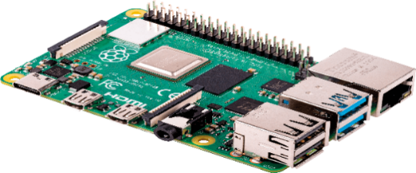

**Fig 1.1 (Raspberry pi)**

Fig 1.1 Elaborates that the Raspberry Pi is a small, low-cost computer that can be used for a variety of projects. It is often used in education and DIY projects, such as building home automation systems, creating media centers, and running retro gaming software. In terms of AI-based and controlled smart agriculture, the Raspberry Pi can be used to control and monitor various aspects of the agricultural field, such as soil moisture levels, temperature, and weather conditions. This information can then be used to optimize irrigation and fertilization, as well as predict crop yields. Additionally, the Raspberry Pi can be used to control and monitor drones or other autonomous vehicles that are used for crop spraying or other tasks. Image processing is also another area where Raspberry Pi could be used in smart agriculture. By capturing images of plants and analyzing them, it's possible to detect various types of plant diseases and pests. This can be done by training a machine learning model on a dataset of images of healthy and diseased plants. The model can then be deployed on the Raspberry Pi and used to analyze new images of plants in the field. This can help farmers detect plant diseases early on and take appropriate action to prevent significant damage to their crops. Overall, the Raspberry Pi's low cost, flexibility, and powerful computing capabilities make it a popular choice for a wide range of agricultural applications, including precision farming, precision irrigation and plant disease detection using image processing.

**II. Soil Moisture Sensor:**

Soil moisture sensors play a vital role in modern agriculture and environmental monitoring. These sensors are designed to measure the moisture content in the soil, providing valuable data for effective irrigation management and plant health monitoring. By accurately detecting the moisture levels in the soil, farmers and gardeners can optimize water usage and prevent both overwatering and under watering, thereby promoting efficient crop growth and reducing water wastage. Soil moisture sensors work by utilizing various techniques such as electrical resistance, capacitance, or frequency domain measurements to assess the soil's water content

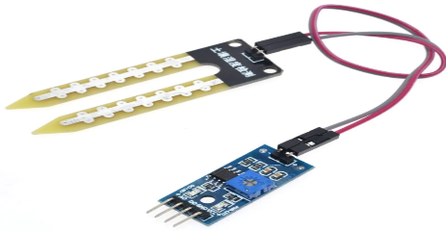

**Fig 1.2 (Soil Moisture Sensor)**

Fig 1.2 involved that the Measuring soil moisture is vital for agricultural applications, to assist farmers manage their irrigation systems more efficiently. Farmers who know the exact soil moisture conditions on their fields can not only use less water to grow a crop, but they can also increase yields and crop quality by better managing soil moisture throughout important plant growth phases. Soil monitoring has become one of the most difficult agricultural fields for both manufacturers and farmers to master. Moisture content, wetness, fertilizer application, and temperature changes are all monitored in the soil. Soil humidity and moisture sensors are used in the moisture environment management system. The results of a soil monitoring test report assist farmers in enhancing crop output by recommending a suitable fertilizer method. Both analogue and digital outputs can be read by the sensor. The decision is based on sensor data that is compared to predetermined threshold levels. The irrigation system's autonomous functioning is controlled by the soil moisture sensor. The water pump is activated when the moisture level falls below the threshold value. Checking if plants have enough moisture to grow is possible with relatively inexpensive and simple gadgets that do not require a power source. A meter determines if the soil is too dry, damp, or wet for plants after placing a probe into the soil for about 60 seconds.

**III. Soil pH Sensor:**

Soil pH sensors are essential tools used in agriculture, horticulture, and environmental research to measure the acidity or alkalinity of the soil. pH levels in soil directly impact nutrient availability, microbial activity, and overall plant health. Soil pH sensors provide accurate and reliable measurements of soil pH, allowing farmers and researchers to make informed decisions regarding soil management and plant nutrition. These sensors typically utilize electrodes or probes that are inserted into the soil to measure the hydrogen ion concentration, which determines the soil's pH value. The collected data is then processed and displayed, providing valuable insights into soil conditions. Soil pH sensors enable farmers to monitor pH levels and make necessary adjustments through soil amendments or fertilizers to maintain the optimal pH range for specific crops

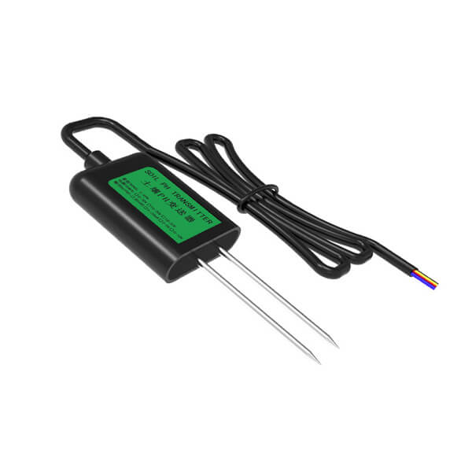

**Fig 1.3 (Soil pH Sensor)**

Fig 1.3 demonstrates that in an AI-based and controlled smart agricultural field, a soil pH sensor can be used to measure the acidity or alkalinity of the soil. The pH level of the soil is an important factor in determining the health and growth of plants. The pH level can affect the availability of nutrients in the soil and can also indicate the presence of certain diseases or pests. A soil pH sensor typically consists of a probe that can be inserted into the soil, and a circuit board that processes the data and sends it to a microcontroller or computer. The sensor measures the voltage difference between the pH-sensitive electrode and a reference electrode, and converts it into a pH value. When using a Raspberry Pi to control and monitor the smart agricultural field, the soil pH sensor can be connected to the Raspberry Pi's general-purpose input/output (GPIO) pins. The specific pin number will depend on the sensor used, but common pins used for this purpose are pin number 4 (5V) and 6 (Ground) and Analog or I2C pins for data transfer. It's always best to consult the sensor's datasheet or the manufacturer's documentation for specific pin connections and usage instructions.

**IV. Temperature/Humidity Measure Sensor (DHT11 Sensor):**

The DHT11 sensor is a popular and cost-effective temperature and humidity measuring device used in various applications, including weather monitoring, indoor climate control, and environmental sensing. This sensor consists of a temperature sensor and a humidity sensor integrated into a single module. It utilizes a digital signal output, making it easy to interface with microcontrollers and other electronic systems. The DHT11 sensor is capable of measuring temperatures ranging from 0°C to 50°C with an accuracy of ±2°C and relative humidity ranging from 20% to 90% with an accuracy of ±5%. It operates by converting the analog signals from the temperature and humidity sensors into digital signals that can be read by the connected microcontroller. With its compact size and low power consumption, the DHT11 sensor is suitable for both portable and stationary applications. It provides valuable data on temperature and humidity levels, allowing users to monitor and control environmental conditions effectively. Whether it is optimizing indoor comfort, monitoring greenhouse conditions, or integrating weather stations, the DHT11 sensor offers a cost-efficient solution for temperature and humidity measurements.

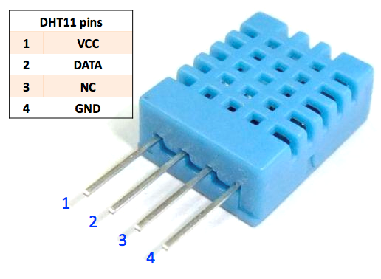

**Fig 1.4 (Temperature/Humidity Measure Sensor (DHT11 Sensor)**

Fig 1.4 elaborate that the temperature Sensors quantify the amount of heat energy or even coldness produced by an object or system, allowing us to "sense" or detect any physical change in that temperature and produce an analogue or digital output. Humidity refers to the amount of water vapor in the air. Humidity in the air has an impact on a variety of physical, chemical, and biological processes. Humidity can have an impact on the business cost of products, as well as the health and safety of people in industrial settings. As a result, humidity measurement is critical in semiconductor and control system industries. Humidity measurement measures how much moisture is present in a gas, which can be a mixture of water vapor, nitrogen, argon, or pure gas, among other things. Humidity sensors are classified into two categories based on the measuring units they use. A relative humidity sensor and an absolute humidity sensor are the two types. The DHT11 is a temperature and humidity sensor that is digital. The temperature and humidity of the field are monitored via the DHT11 sensor. In addition, when an intruder (human or animal) enters the area, a PIR motion sensor detects it. As a result, with a GSM sim900A module, which comprises a sim card with a 3G data pack and adds A.I capabilities to the system, sensor values are continuously monitored and presented on the farmer's mobile device.

**V. Light Dependent Sensor (LDR):**

The Light Dependent Resistor (LDR), commonly known as a light sensor or photocell, is a sensor that measures light intensity in its surroundings. LDRs are widely used in various applications, including automatic lighting systems, solar panels, and photography equipment. They work based on the principle of the photoconductive effect, where the resistance of the LDR changes with the amount of light falling on it. In bright light conditions, the resistance of the LDR decreases, allowing more current to flow through it. Conversely, in low light conditions, the resistance increases, restricting the current flow. This inverse relationship between resistance and light intensity makes LDRs ideal for detecting ambient light levels. The output of the LDR can be analog or digital, depending on the circuit design and the requirements of the application. LDRs are simple to use and can be easily integrated into electronic systems, such as microcontrollers or Arduino boards, for light sensing purposes. Their versatility and affordability make them a popular choice for a wide range of light-dependent applications, enabling precise and automated control based on the surrounding light conditions.

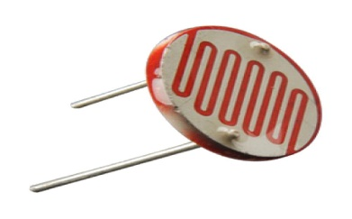

**Fig 1.5 (Light Dependent Sensor)**

Fig 1.5 Explains that the LIGHT DEPENDENT SENSOR LDRs (light dependent resistors) or photo resistors, are electronic components that are frequently employed in electronic circuit designs when the presence or level of light must be detected. LDRs are distinct from other types of resistors, such as carbon film resistors, metal oxide film resistors, and metal film resistors, which are commonly used in electrical circuits. They were created expressly for their light sensitivity and the resulting resistance change. The light delight-dependent, LDR, photoresist or, or even photocell, photocell, or photoconductor are all names for these electrical components. Although other electrical components such as photodiodes or phototransistors can be employed, LDRs or photo-resistors are especially useful in many electronic circuit designs. For variations in light level, they produce a considerable shift in resistance. LDRs have been employed in a wide range of applications due to their inexpensive cost, ease of fabrication, and ease of use. LDRs were once utilized in photographic light meters, and they are currently used in a number of applications where light levels need to be detected. LDR or photo resistor can be used to measure the quantity of light received on a plot of land. Depending on the amount of light falling on it.

**VI. Submersible Mini Water Pump:**

A submersible mini water pump is a compact and efficient device designed to move water or other fluids in various applications. These pumps are specifically designed to be submerged in liquids, making them suitable for tasks such as water circulation, fountain displays, aquariums, hydroponics, and small-scale irrigation. The submersible design allows the pump to be fully immersed in the water, eliminating the need for priming or external suction. This makes them easy to install and operate. Despite their small size, submersible mini water pumps are capable of delivering a considerable flow rate and can handle a range of fluid viscosities. They are typically equipped with a motor that drives an impeller, generating the necessary centrifugal force to move the fluid. The pumps are often constructed with durable materials like stainless steel or corrosion-resistant plastic to ensure reliable and long-lasting performance, even in harsh environments. With their compact size, quiet operation, and efficient pumping capabilities, submersible mini water pumps provide a convenient and effective solution for various water-related tasks in both residential and commercial settings.

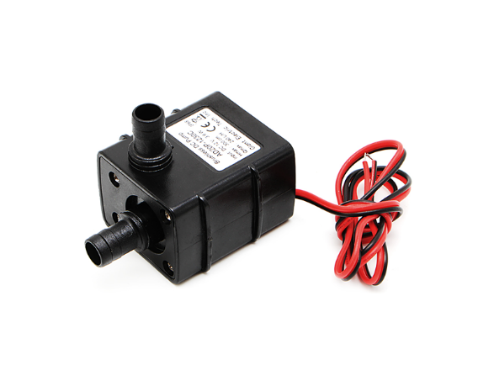

**Fig 1.6 (Submersible Mini Water Pump)**

Fig 1.6 intricate that in an AI-based and controlled smart agricultural field, a 12V water pump can be used to pump water from a source, such as a well or a reservoir, to the fields for irrigation. The water pump can be controlled and monitored by a Raspberry Pi or other microcontroller, which can be programmed to turn the pump on and off based on various factors such as the soil moisture level, the weather conditions, and the crop's water requirements. To connect a 12V water pump to a Raspberry Pi, a relay module can be used. The relay module is an electronic switch that allows the Raspberry Pi to control the flow of electricity to the water pump. The relay module connects to the Raspberry Pi's general-purpose input/output (GPIO) pins, and can be controlled using software commands. It's important to note that the Raspberry Pi itself doesn't have the capability to supply the power to drive the water pump, as it operates on low voltage and requires a separate power source. A 12V power supply is required to power the water pump and the relay module. The relay module will be connected to the power supply and the raspberry pi, it will be controlled by the raspberry pi which will send a signal to the relay to turn the pump on or off. It's always best to consult the water pump's datasheet or the manufacturer's documentation for specific usage instructions and safety precautions.

**VII. Pi Camera:**

The Pi Camera, also known as the Raspberry Pi Camera Module, is a compact camera designed specifically for use with Raspberry Pi single-board computers. It offers a cost-effective and versatile solution for capturing images and videos in various projects and applications. The Pi Camera module connects directly to the CSI (Camera Serial Interface) port on the Raspberry Pi, eliminating the need for additional cables or adapters. It provides high-quality imaging capabilities with adjustable focus and supports different resolutions, including still images up to 12 megapixels and video recording at various frame rates. The camera module can be controlled

programmatically using Python or other programming languages, allowing users to customize the camera's functionality as per their project requirements. With its small size and low power consumption, the Pi Camera is well-suited for applications such as security systems, robotics, time-lapse photography, surveillance, and more. Whether you are a hobbyist or a professional developer, the Pi Camera opens up a world of possibilities for capturing and analyzing visual data with your Raspberry Pi

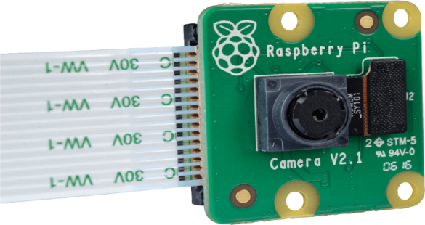

**Fig 1.7 (Pi Camera)**

Fig 1.7 sophisticates that an AI-based and controlled smart agricultural field, a Raspberry Pi camera can be used to capture images of the field and the crops. These images can be used to monitor the health and growth of the plants, detect plant diseases, and predict crop yields. The camera can also be used to monitor the weather conditions, such as cloud cover and precipitation, and to capture images of the field for mapping and navigation purposes. The Raspberry Pi camera can be connected to the Raspberry Pi using a ribbon cable, and can be controlled using software commands. The Raspberry Pi camera module is capable of capturing images and videos in various resolutions, and can be configured to take pictures at specific intervals or to capture images in response to certain events. The captured images can then be analyzed using image processing techniques, such as object detection and image classification, to detect plant diseases and predict crop yields. The image processing can be done on the Raspberry Pi or the images can be sent to a cloud service for processing. It’s important to note that for accurate plant disease detection, training of a machine learning model with a dataset of images of healthy and diseased plants is crucial. This can be done with the help of pre-trained models or by training your own model with a dataset of images of plants specific to your agricultural field. It’s always best to consult the Raspberry Pi camera module's datasheet or the manufacturer's documentation for specific usage instructions and compatibility with different versions of Raspberry Pi.

**VIII. Four Channel Rely Module:**

A Four Channel Relay Module is an electronic device designed to control multiple electrical circuits or devices using low-voltage signals. It acts as a switch that can control the on/off state of four independent channels. Each channel on the relay module consists of an electromechanical relay, which is capable of handling higher voltages and currents than what the controlling circuit can handle. This makes it ideal for applications where the control signals are low voltage, such as with microcontrollers or Arduino boards. The relay module is typically equipped with opt couplers, which provide electrical isolation between the control circuit and the high-voltage side, ensuring safety and preventing interference. The module can be easily interfaced with microcontrollers or other digital control systems through GPIO pins, allowing for easy integration and control of various electrical devices, such as lights, motors, pumps, and appliances. It offers a convenient and efficient solution for home automation, robotics, industrial control systems, and other projects where multiple devices need to be controlled simultaneously. With its compact size, ease of use, and versatility, the Four Channel Relay Module is a valuable component for anyone looking to build automation or control systems.

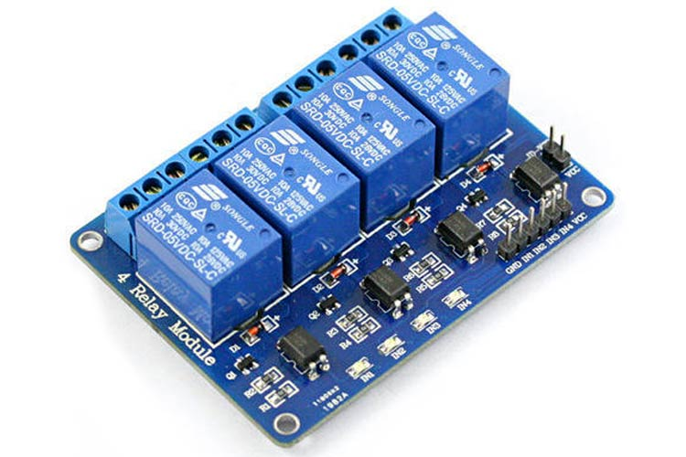

**Fig 1.8 (Four Channel Rely Module)**

Fig 1.8 elaborates that the A 4-channel relay module can be used in a Raspberry Pi project to control high voltage devices such as lights, fans, pumps, and motors using the low voltage of the Raspberry Pi's GPIO pins. The relay module acts as a switch that can be controlled by the Raspberry Pi, allowing it to turn devices on and off based on sensor readings or other conditions. In an AI-based and controlled smart agricultural field, a 4-channel relay module can be used to control multiple devices such as a 12V fan, a bulb, and a 12V water pump. The relay module can be controlled by the Raspberry Pi, which can be programmed to turn the devices on and off based on sensor readings or other conditions. Once the 4-channel relay module is connected to the Raspberry Pi, you can use a programming language such as Python to control the relay and turn on or off the fan, bulb, and water pump based on sensor data or other conditions. The Raspberry Pi can be configured to receive sensor data from various sensors such as temperature sensor, soil moisture sensor and based on that data the device can be turned on or off.

**IX. 12 Volt Fan:**

A 12-volt fan is a cooling device designed to operate using a 12-volt direct current (DC) power source. These fans are commonly used in a variety of applications, including computer cooling systems, automotive cooling, ventilation in enclosed spaces, and electronics cooling. The 12-volt power requirement makes them compatible with a wide range of devices, such as vehicles, solar-powered systems, and portable electronics. 12-volt fans are typically compact and lightweight, making them easy to install and transport. They come in various sizes and designs, including axial fans and centrifugal fans, with different airflow capacities and noise levels. These fans are known for their energy efficiency, drawing low power while still providing effective cooling. Many 12-volt fans also offer adjustable speed control options, allowing users to regulate the fan speed according to their cooling needs. With their reliable performance and versatile applications, 12-volt fans play a crucial role in maintaining proper airflow and preventing overheating in various systems, ensuring optimal performance and longevity.

**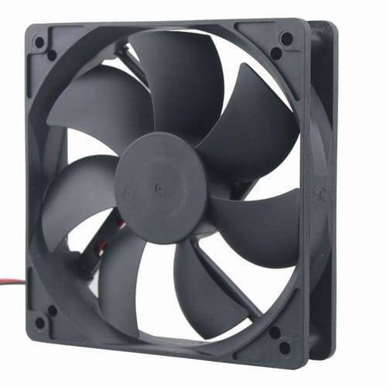  
Fig 1.9 (12 Volt Fan)**

Fig 1.9 demonstrates that in an AI-based and controlled smart agricultural field, a 12V fan can be used to provide ventilation and cooling for the plants. The fan can be controlled by the Raspberry Pi, which can be programmed to turn the fan on and off based on temperature or humidity readings from sensors. To connect a 12V fan to the Raspberry Pi in an agricultural field setting, you will need the following components: A 12V fan relay module breadboard or PCB to connect the components set of male-to-female jumper wires. The relay module is used to switch the high voltage (12V) of the fan on and off using the low voltage (3.3V or 5V) of the Raspberry Pi's GPIO pins. The fan is connected to the normally open (NO) terminal of the relay, and the Raspberry Pi is connected to the control terminal of the relay using a jumper wire. The GND pin should be connected to the GND pin on the Raspberry Pi. The VCC pin should be connected to the 3.3V or 5V pin on the Raspberry Pi. The IN pin should be connected to one of the GPIO pins on the Raspberry Pi, which will be used to control the relay. Once the fan is connected to the Raspberry Pi, you can use a programming language such as Python to control the fan. The Raspberry Pi can be configured to receive temperature and humidity data from various sensors such as DHT11 and based on that data the fan can be turned on or off.

**X. LCD 16x2:**

An LCD 16x2 (Liquid Crystal Display 16x2) is a commonly used alphanumeric display module that consists of 16 columns and 2 rows, resulting in a total of 32 characters. It serves as an output device that can display text, numbers, and symbols, making it suitable for various applications such as digital clocks, temperature displays, menu interfaces, and data monitoring systems. The LCD 16x2 module utilizes liquid crystal technology, where electrical currents control the orientation of liquid crystal molecules to form characters on the screen. It typically has a backlight that enhances visibility in different lighting conditions. The module is compatible with microcontrollers, Arduino boards, and other digital systems, allowing for easy integration and control. Communication with the LCD 16x2 module is achieved through a simple interface, which involves sending commands and data using digital signals. With its compact size, low power consumption, and clear display capabilities, the LCD 16x2 is a popular choice for projects that require a simple and cost-effective alphanumeric display solution.

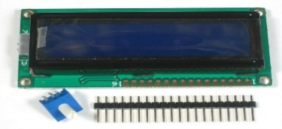

**Fig 1.10 (LCD 16x2)**

Fig 1.10 explains that an AI-based and controlled smart agricultural field, a 16x2 LCD can be used to display real-time information such as sensor readings, weather data, and crop health status. The LCD can also be used to display messages and alerts, such as a warning when a plant is diseased, or a notification when the soil moisture is low. To connect the LCD to the Raspberry Pi in an agricultural field setting, the same components are needed as mentioned earlier: A 16x2 LCD screen. A breadboard or PCB to connect the components a set of male-to-female jumper wires. A potentiometer (10K) to adjust the contrast of the LCD. The specific pin configuration of the LCD depends on the manufacturer and the model of the LCD. Once the LCD is connected to the Raspberry Pi, you can use a programming language such as Python to control the LCD and display messages.

**XI. Gas Sensor:**

A gas sensor is a device designed to detect and monitor the presence of various gases in the surrounding environment. These sensors play a crucial role in ensuring safety, environmental monitoring, and industrial processes. Gas sensors utilize different technologies to detect specific gases, such as carbon monoxide (CO), methane (CH4), hydrogen (H2), ammonia (NH3), and more. They can operate based on various principles, including electrochemical, catalytic, infrared, and semiconductor technologies. When a gas comes into contact with the sensing element of the sensor, it triggers a chemical or physical reaction, which generates a measurable electrical signal. This signal is then processed and analyzed to determine the concentration of the target gas. Gas sensors are widely used in industries such as manufacturing, oil and gas, agriculture, and environmental monitoring. They are also commonly found in residential and commercial settings to ensure the safety of occupants by detecting hazardous gases like carbon monoxide. Gas sensors enable early detection of gas leaks, facilitate the monitoring of air quality, and help prevent accidents or health hazards associated with the presence of certain gases. With their accuracy, reliability, and ability to provide real-time data, gas sensors play a vital role in maintaining safety and improving the quality of our environment.

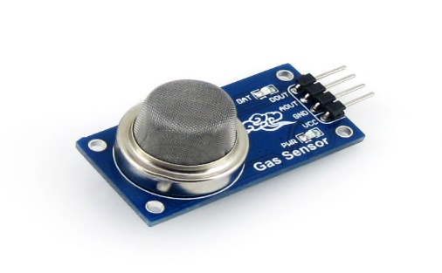

**Fig 1.11 (Gas Sensor)**

Fig 1.11 involved that the MQ series Gas sensors shown in Figure 1.4.4.11 are the most affordable and widely used when it comes to measuring or detecting a specific Gas. MQ135 can be purchased as a module or as a single sensor. If you merely want to detect the presence of a gas rather than measure PPMs, you may buy it as a module, which includes an op-amp comparator and a digital output pin. However, if you want to measure the PPM of gas, you should buy the sensor without the module. The MQ-135 Gas Sensors are excellent for detecting or measuring NH3, NOx, Alcohol, Benzene, Smoke, and CO2 in air quality control systems. The MQ-135 sensor module has a Digital Pin, which allows it to work without a microcontroller, which is useful when you simply want to detect one gas. If you need to measure gases in PPM, you'll need to use the analog pin. The analog pin is TTL-driven and operates at 5V, making it compatible with a wide range of microcontrollers.

**XII. Barometric Pressure Sensor:**

A barometric pressure sensor, also known as a barometer, is a device used to measure atmospheric pressure. It provides valuable information about changes in weather patterns and can be used for altitude measurement as well. Barometric pressure sensors utilize various technologies, such as piezo resistive, capacitive, or optical, to detect and convert atmospheric pressure into an electrical signal. These sensors are often integrated into electronic devices, weather stations, altimeters, and navigation systems. They are designed to accurately measure the pressure exerted by the Earth's atmosphere and provide readings in units such as Pascal (Pa), milliard (mbar), or inches of mercury (inHg). The data collected by barometric pressure sensors can be used to predict weather conditions, monitor changes in air pressure, and provide valuable insights for aviation, meteorology, and outdoor activities. Barometric pressure sensors are highly sensitive and can detect even subtle changes in atmospheric pressure.

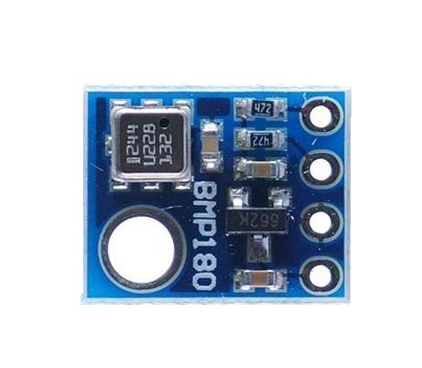

**Fig 1.12 (Barometric Pressure Sensor)**

Fig 1.12 elaborates that a barometric pressure sensor can be used to monitor atmospheric pressure. In the short term, atmospheric pressure data can be used to anticipate weather, and it can also be used to research how plants behave under various atmospheric pressure circumstances. The best low-cost sensing solution for monitoring barometric pressure and temperature is Bosch's precision sensor. You can also use it as an altimeter because pressure fluctuates with height. A 3.3V regulator, I2C level shifter, and pull-up resistors on the I2C pins are attached onto a PCB with the sensor. The BMP180 is Bosch's next generation of sensors, succeeding the BMP085. The good news is that in terms of firmware/software, it's a drop-in replacement for the BMP085

**XIII Analog to Digital (MCP3008):**

The MCP3008 is an analog-to-digital converter (ADC) integrated circuit commonly used to convert analog signals into digital data. It offers eight channels of 10-bit resolution, allowing the conversion of multiple analog inputs into corresponding digital values. The MCP3008 operates on a single supply voltage and communicates with a microcontroller or other digital devices through a serial interface, such as SPI (Serial Peripheral Interface). This makes it compatible with a wide range of microcontrollers and provides an efficient way to interface analog sensors or signals with digital systems. The MCP3008 provides accurate and reliable analog-to-digital conversion, enabling precise measurements and data acquisition. Its versatility and ease of use make it suitable for various applications, including sensor interfacing, data logging, automation, and control systems. With the MCP3008, analog signals can be effectively digitized and processed, allowing for further analysis, manipulation, and utilization in digital systems. Whether it's for hobbyist projects or professional applications, the MCP3008 serves as a valuable tool for integrating analog signals into digital environments.

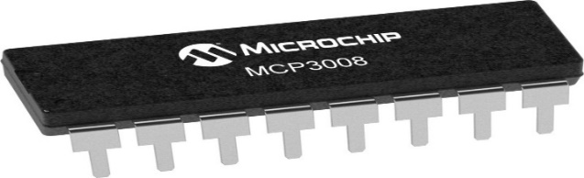

**Fig 1.13 (Analog to Digital MCP3008)**

Fig 1.13 involved that the MCP3008 is a 10-bit analog-to-digital converter (ADC) that can be used to interface analog sensors such as a light-dependent resistor (LDR) with a microcontroller, such as a Raspberry Pi. The MCP3008 can be used to convert the analog voltage output of the LDR sensor into a digital value that can be read by the Raspberry Pi and used to measure the light intensity. Once the MCP3008 is connected to the Raspberry Pi, you can use a programming language such as Python to read the analog value from the LDR.

# Chapter # 2

**Literature Review**

This article represents, brilliant agribusiness checking expects to give the agrarian business a high-level mechanical foundation that might incorporate web of things (IOT), distributed computing, and man-made consciousness (simulated intelligence) in handling the information got from numerous sensors sent in-ground gadgets, (un)manned aeronautical vehicles (UAVs) and satellites. The examination in simulated intelligence has gone through a prospering stage over the most recent couple of many years where independent frameworks have accomplished close ideal correctness’s in fields like language handling, text acknowledgment, picture understanding, and voice ID, to give some examples. All in all, the analysts have been enormously effective in creating managed order models with negligible human association. As of late, the center has moved to planning strong and versatile man-made intelligence grouping models that can work under a serious shortage of preparing information, loud conditions, or in a circumstance when the likelihood circulation of the test tests is dissimilar from the ones in the preparation set. A ton of these can be credited to the coming of profound learning-based acknowledgment models through which the ongoing age man-made intelligence calculations are more than fit for taking care of oddities and differences in reality unstructured information. Attributable to these advancements in the new past, this section is committed to another feature in man-made intelligence research where multi-modular information from various sensors are dissected, handled, and coordinated into a framework for the advancement of an improved multi-sensor grouping mode [1].

Agriculture has seen numerous unrests, whether the taming of animals and plants a couple quite a while back, the efficient utilization of yield turns and different upgrades in cultivating practice two or quite a while back, or the "green upheaval" with precise reproducing and the broad utilization of man-made composts and pesticides years and years prior. We recommend that horticulture is going through a fourth transformation set off by the dramatically expanding utilization of data and correspondence innovation (ICT) in agribusiness Independent, mechanical vehicles have been produced for cultivating, like mechanical weeding, use of compost, or collecting of natural products. The improvement of automated aeronautical vehicles with independent flight control, along with the advancement of lightweight and strong hyperspectral depiction cameras that can be utilized to work out biomass improvement and treatment status of yields, opens the field for modern ranch the board guidance. Also, choice tree models are accessible now that permit ranchers to separate between plant illnesses in view of optical data. Virtual wall advances. Permit dairy cattle group the executives in view of remote-detecting signs and sensors or actuators connected to the animals. Shop cultivating can give a coordinated way out of secured in advancements and practices portrayed areas of strength for by and market division. It offers a way toward supportable farming by broadening of innovations, yield and domesticated animals’ creation frameworks, and organizations across all entertainers of the agro-food area. Plans of action could make added esteem by changing over spatially express large information into data, guidance for ranchers [2]

Savvy cultivating (SF) includes the consolidation of data and correspondence advancements into hardware, gear, and sensors for use in horticultural creation frameworks. New innovations, for example, the web of things and distributed computing are supposed to propel this turn of events, presenting more robots and man-made consciousness into cultivating. Accordingly, the points of this paper are twofold: to portray the logical information about SF that is accessible in the overall logical writing in light of the principal elements of advancement by country and over the long run and to depict current SF possibilities in Brazil according to the viewpoint of specialists in this field. The examination included leading semi-organized interviews with market and specialist specialists in Brazil and utilizing a bibliometric overview through information mining programming. Coordination between the different accessible frameworks available was recognized as one of the really restricting variables to SF advancement. Another restricting element is the training, capacity, and abilities of ranchers to comprehend and deal with SF devices. These constraints uncovered a market an open door for ventures to investigate and assist with tackling these issues, and science can add to this cycle. China, the US, South Korea, Germany [3].

This article involved that Farming is by its inclination a muddled logical field, connected with an extensive variety of mastery, abilities, strategies and cycles which can be really upheld by modernized frameworks. There have been numerous endeavors towards the foundation of a mechanized agribusiness system, proficient to control both the approaching information and the comparing processes. The new advances in the Data and Correspondence Advances (ICT) space have the capacity to gather, process and break down information from various sources while emerging the idea of agribusiness knowledge. The flourishing climate for the execution of various horticulture frameworks is legitimate by a progression of innovations that offer the possibility of working on rural efficiency through the concentrated utilization of information. The idea of large information in farming isn't solely connected with huge volume, yet additionally on the assortment and speed of the gathered information. Large information is a vital idea for the future improvement of farming as it offers phenomenal capacities and it empowers different devices and administrations proficient to change its ongoing status. This overview paper covers the cutting-edge farming frameworks and large information models both in examination and business status with an end goal to connect the information hole between horticulture frameworks and abuse of enormous information. The initial segment of the paper is given to the investigation of the current horticulture frameworks, giving the important foundation data to their development until they have arrived at the ongoing status, ready to help various stages, handle different wellsprings of data [4].

Environment shrewd farming (CSA) addresses the test of fulfilling the developing need for food, fiber and fuel, in spite of the changing environment and less open doors for agrarian extension on extra terrains. CSA centers around adding to monetary turn of events, destitution decrease and food security; keeping up with and improving the efficiency and versatility of regular and horticultural biological system capabilities, accordingly fabricating normal capital; and lessening compromises associated with meeting these objectives. Ebb and flow holes in information, work inside CSA, and plans for interdisciplinary exploration and science-based activities distinguished at the 2013 Worldwide Science Gathering on Environment Brilliant Agribusiness (Davis, CA, USA) are depicted here inside three subjects: homestead and food frameworks, scene and local issues and institutional and strategy perspectives. The initial two subjects contain crop physiology and hereditary qualities, relief and transformation for domesticated animals and farming, hindrances to reception of CSA rehearses, environment risk the board and energy and biofuels and demonstrating variation and vulnerability, accomplishing multi-functionality, food and fishery frameworks, woods biodiversity and biological system administrations, country movement from environmental change and measurements planning research that scaffolds disciplines, incorporating partner contribution to connect science, activity and administration straightforwardly. Notwithstanding interdisciplinary examination among these subjects, objectives incorporate creating models that incorporate variation and change at either the homestead or scene level; limit ways to deal with look at multifunctional answers for agronomic, biological and financial difficulties; situations that are approved by direct proof and measurements to help ways of behaving that encourage versatility and regular capital [5].

This research Tell us about the Greenhouse is a flexible plastic structure mainly designed for the production of the products inside. Since most traditional greenhouses, particularly in dry locations, numerous environmental factors such as moisture temperature and others have been ignored. Automated technology is used in agriculture to monitor crop development using a quadcopter and achieve massive emerging food manufacturing requirements. The development of remote sensing in the greenhouse environment has been important for less costly innovations for farmers to recover production. A greenhouse is a construct with a light source that can maintain temperature control, the required moisture, and light absorption for the healthy development of a production facility. Agricultural production is a system that involves the detection, measurement of crops. It is a technology for recognizing greens, and messages are transferred to the server at this moment, and action is needed from the farmer given the information he obtains. In the servant, various sensors are employed for temperature for monitoring the ammonium and moisture sensing. This means that greenhouse factors such as CO2, soil moisture, temperature, and light can be monitored. The unstable environment in greenhouse crops can affect plant development and reduce yield towards the end of culture. This challenge can be addressed by applying IOT innovations in artificial intelligence applications for certain greenhouse factors controlling temperature range, water flow, and light radiation. This agricultural instability can gradually increase with the emergence and this method has been involved in the continuous development of artificial intelligence. Remote sensing data with high resolutions and real-time agricultural production crop yield sampling are appropriate machine-learning technology in commercial crop prediction. In the agricultural sector, machine learning is utilized to increase crop output and quality. Seed dealers use this agriculture technology to churn data to develop better crops. Agricultural products are employed as raw materials in various supply networks to create higher-value consumer products. This development was supposed to lead to the use of new technology in agricultural production. Manufacturing requires global prospects for agriculture smart production technologies to achieve sustainable development. Thus, the proposed work systematically analyzed research articles on artificial intelligence and machine learning in the industry. In this context, various AI-based approaches, including machine learning, were developed to achieve sustainable manufacturing by extensive research and development in Artificial Intelligence [6].

AGRICULTURE 6 3, PP 237–244.Image processing has been proved to be effective tool for analysis in various fields and applications. Agriculture sector where the parameters like canopy, yield, quality of product were the important measures from the farmers’ point of view. Many times, expert advice may not be affordable, majority times the availability of expert and their services may consume time. Image processing along with availability of communication network can change the situation of getting the expert advice well within time and at affordable cost since image processing was the effective tool for analysis of parameters. This paper intends to focus on the survey of application of image processing in agriculture field such as imaging techniques, weed detection and fruit grading. The analysis of the parameters has proved to be accurate and less time consuming as compared to traditional methods. Application of image processing can improve decision making for vegetation measurement, irrigation, fruit sorting, etc. In image processing source of radiation was important and the sources were Gamma ray imaging, X-ray imaging, imaging in UV band, imaging in visible band and IR band, imaging in Microwave band and imaging in Radio band. In agriculture, Remote Sensing (RS) technique was widely used for various applications. Remote Sensing was the science of identification of earth surface features and estimation of geo-biophysical properties using electromagnetic radiation. Paper reviewed the RS techniques and its applications with optical and microwave sensors. Author discussed about the satellites launched by different countries and their uses in various field along with spatial, spectral and temporal variations of data. Analytical techniques using digital image processing, multi-source data fusion and GIS were also discussed. Applications towards agriculture providing the earth observation data which supports increased area under agriculture, increased crop intensity and productivity, etc. RS data can provide the data related to groundwater helping in irrigation, flood management. Applications like environment assessment and monitoring, disaster monitoring and mitigation, weather climate, village resource center, etc. were also discussed. RS data and pattern recognition technique was used to estimate direct and independent crop area in the study region. In this review the authors reviewed the die rent techniques for crop inventory in Indian scenario. Optical and microwave data used to classify the crop. Chlorophyll and water were represented by optical data, crop geometry and dielectric properties were characterized by microwave. The crop discrimination was carried out using either by visual or digital interpretation techniques. Visual techniques based on FCC (False Color Composite) were generated at different bands and were assigned with blue, green and red colors whereas the digital techniques applied to each pixel and use full dynamic range of observations were preferred for crop discrimination. For accurate discrimination a multi-temporal approach was used when single date data fails to do so. Spectral unfixing, direct estimation, crop area estimation, global estimation using confusion matrix and regression estimator were also reviewed. RS used for mapping vegetation which provides information of manmade and natural environments. The focus of review was on remote sensing sensors, image processing algorithms to extract vegetation information along with classification and limitations [7].

In this paper, we first discussed the importance of smart agriculture practices with the growing gaps in global food demand versus current food generation, the growing shortage of arable land for agriculture, stricter regulations by international organizations on the use of toxic pesticides/herbicides, and global shortage of water resources for irrigation purpose. Clearly, all of the challenges cannot be met through traditional agricultural practices. We then discussed in detail the current hardware building blocks of the smart agriculture system, which is primarily based upon a large number of IOT nodes deployed in the field with suitable sensors to monitor the current situations of crops. The monitored parameters are transmitted wirelessly through various available technologies for the farmer to take remedial actions manually or automatically through pre-programmed instructions to actuators. We discuss the automated control algorithms and strategies along with their advantages and limitations for one particularly important application, smart irrigation, in view of recently depleting water resources. We also discussed the currently available and implemented hardware, wireless communications technologies, and software aspects of the smart agriculture systems in terms of implementation with their use-cases and limitations. These use-cases will define their potential roles in newer Smart Agriculture standards and specifications as they evolve. Next, we presented a detailed insight into the emerging trends of applications of AI and DL in smart agriculture and the architectural building blocks for smart agriculture systems. We discussed at length practical prototype implementations and their effectiveness for applications in automated plant disease or pest detection. We also briefly discussed the impact of these technologies on future advancements in smart agriculture, such as the use of UAV/drones and other smart farming machinery. Finally, we discussed the challenges of smart agriculture systems to support the paradigm shift of adopting the latest technological advancements for mainstream systems. The foremost is the social implication of these technological advancements on traditional farming methods. These advanced techniques may redefine the way the farmers will practice agriculture in the years to come. Farmers will have to be tech-savvy to keep themselves abreast with these technological advancements, and traditional farming practices will become obsolete and impractical. Other technical challenges include standardization aspects of commercially available smart agriculture systems solutions to make them compatible across several manufacturers, make them backward compatible and lower costs associated with the wide adoption of smart agriculture systems. In the end, we also discussed the future directions of advancement in smart agriculture systems and the technological difficulties and challenges they will bring with them [8].

As exploration and development around Brilliant Cultivating further advances, there is a need to consider the effect of these innovations including the financial, social and social issues that might emerge from their reception. The ongoing review investigates the apparent dangers and advantages emerging from the improvement of Savvy Cultivating in Ireland and specifically centers around the various understandings credited to take a chance with issues by various entertainers. Semi-organized interviews were brought out with 21 entertainers who through their expert positions have some degree of obligation regarding the development of Brilliant Cultivating in Ireland. Albeit the members in the ongoing review were generally in arrangement about the advantages introduced by Savvy Cultivating for Irish farming and society, they held various understandings and suppositions while examining distinguished chances. The principal concerns connected with shopper dismissal of innovations, unjust dissemination of dangers and advantages inside the cultivating local area, unfavorable financial effects of expanded rancher innovation associations, and moral dangers introduced by the assortment and sharing of ranchers' information. The ongoing review builds up how equivocalness can encompass the conversation of dangers as people structure discernments in light of different worth decisions. The discoveries build up the call for talk based administration of dangers and the inserting of systems like Dependable Exploration and Advancement inside Savvy Cultivating. Seen by a larger number of people as significant for the future achievement and maintainability of the horticultural area, Brilliant Cultivating can possibly upgrade and change how homesteads are overseen and worked (Kamila is et al., 2017; WOLFERT et al., 2017a). The approach of Shrewd Cultivating in farming offers energizing turns of events yet in addition expected difficulties and dangers, similar to the situation where any new advancements are brought into society (SONKA, 2014). there is a shortage of observational information and information on current financial effects of digitization. Research is expected to address this and to graph and make arrangements for future effects.[9].

Since the beginning of the 20th century, agriculture has been advancing continuously to precision agriculture, commonly referred to as agriculture 3.0, through the adoption of new technologies, such as GPS, satellite imaging and advanced image analysis. Smart farming 4.0 is posed to significantly advance the state-of-the-art of agriculture through the integration of a broad range of additional advanced technologies, including Internet-of-things (IOT), cloud computing, etc. In the report, “The future of technology in agriculture” published by a Netherlands research center in 2016, 20 new technologies have been identified to increase agricultural and livestock yield while using less resources and preserving natural environments. They are from many different industries and economic sectors, ranging from finance, engineering, food retailers, to industry associations and groups of small farming suppliers. Due to the diversity and heterogeneity of the stakeholders, it is important to facilitate dialogues and cooperation in the process of developing standards for smart farming and improving interoperability between different systems and technologies. Holistic cyber physical systems for smart farming User-friendly and application-oriented visualization and decision support system Interoperability of heterogeneous devices and actuators Multi-support edge routers and communication protocols Ontology, sensor metadata and semantic data Big data systems and technologies Scalable IOT cloud platforms for small to large farms Massive data integration and fusion Unmanned robotic vehicle, unmanned aerial vehicle, and collaborative processing of remote and proximity sensory data Wireless network access medium, low power Wi-Fi and BLEROBUST, energy efficient and long lifetime architecture of WSN node for outdoor application and field test Robust and low cost user-friendly plug and play wireless sensor node, network architecture and implementation New environment sensor technologies Energy harvesting techniques for battery-less IOT node AI and machine vision for agriculture and aquaculture[10].

This work focuses on new approaches regarding Smart Farming (SF) from 2020 to 2022, which utilizes technologies such as Artificial Intelligence (AI), Internet of Things (IoT), and the mobile web to provide solutions to the food shortage and population growth difficulties facing sustainable development around the world. It also examines the use of Unmanned Aerial Vehicles (UAV) and robots for tasks like harvesting, seeding, weed detection, irrigation, pest spraying, animal applications, etc. Moreover, the importance of 5G mobile networks for high-speed data transfer and connecting a large number of devices per square kilometer is highlighted. Furthermore, the implementation of Smart Decision Support Systems (SDSS) in agricultural nations is discussed to support the current research, soil quality assessment and decision-making. Finally, smart agriculture in non-industrial countries requires additional support from government and private sector [11].

This article says, analysts are creating computerized answers for horticulture. The agrarian area is right now joining new innovations from different regions, which is causing hypothetical and useful difficulties. Our audit found two primary research fronts and 21 primary watchwords or subjects around farming 4.0. We additionally discovered that computerized horticulture is the hub innovations coordination for the computerization of agrarian exercises, however the potential results of these new arrangements can be positive or negative. Future investigations should zero in on the capable improvement of computerized arrangements for agribusiness and guarantee that these advancements don’t intensify social imbalances [12].

They Focus on a savvy cultivating is a farming administration idea that uses trend setting innovation including enormous information, the cloud and the web of things (IoT) for following, checking, robotizing, and dissecting tasks. It assists farmers with better following the necessities of individual animals and change their sustenance to forestall sickness, improve crowd wellbeing, better control rural cycles to decrease creation dangers, and upgrade the capacity to anticipate creation results. 5G systems, little cells, and huge MIMO are being used to modernize the organization foundation and prepare for the 5G rollout [13].

In this article, the authors explore the current literature on environment-friendly agriculture (CSA) and how global associations can assist smallholder farmers with managing agricultural systems to address climate change. The authors conducted a subject modeling approach to identify general CSA topics that can guide large global associations to focus their CSA efforts. They identified eight topics: orientation research, climate and environment, CSA management and food security. They concluded that there is inadequate conversation on the issues connecting with management measures and orientation mainstreaming, with a larger focus on techno administrative aspects of CSA. They suggest that research and training connected with CSA should offer opportunities for underrepresented and overly vulnerable populations to participate and speak up and share creative ideas [14].

This Articles Verify that the farming area is one of the spines of many nations' economies and its Processes have been changing to empower innovative reception to increment efficiency, Quality, and economical turn of events. In this examination, we present a hypothetical reflection through a logical planning of the reception of accuracy strategies and advancement advancements in farming, the purported Accuracy Agribusiness and Horticulture. our outcomes talk about the primary difficulties and chances of DA. Our discoveries can possibly give experiences to specialists and scientists in navigation furthermore, make ready for future works. Agribusiness has been altered after some time, arriving at the ideas of Accuracy Horticulture and Farming that give face to Advanced Horticulture (DA). Thus, we cover a gap in the literature related to the evolution of the digitalization of agriculture and its strategic themes over time. In spite of its commitments, this examination has constraints. This study investigated just archives from the Trap of Science data set and we investigate just the topical designs of the engine subjects, and different topics could be tended to in ongoing works [15].

This paper is to propose a Shrewd IOT based Horticulture Stick that will farmers in getting live Information of Temperature, Soil Dampness, and so on and different variables for proficient climate observing which will assist them with doing brilliant cultivating and increment their general yield and nature of items. The Horticulture stick being proposed through this paper is coordinating with Arduino Innovation, Breadboard and blended in with various different sensors and live information feed can be gotten web based through cell phone. Furthermore, the frameworks created by association of various equipment gadgets are being executed under different various states of soil. The IOT based Horticulture stick being created through this paper will help farmers in expanding the horticulture yield and take effective consideration of food creation as the stick will continuously give assistance to farmers for getting exact live feed of ecological temperature and soil dampness with exact outcomes [16].

Starting around 2011, the CGIAR program on Environmental Change, Farming and Food Security (CCAFS) has upheld research in various regions of earth on how environment advances, practices and data can address the test of progressing to climate smart horticulture under the factors of environmental change. The functioning paper basically looks at how CCAFS scientists have conceptualized and drilled the scaling of environment brilliant farming intercessions. The survey of CCAFS research is supplemented by a conversation of a portion of the new sociology writing on scaling and firmly related points, for example, development and systematization. Albeit all the more as of late the reasonable, systemic and pragmatic difficulties connected with scaling of environment brilliant horticulture definitely stand out, there stays a requirement for the improvement of a more lucid hypothesis of scaling informed by experiences from humanism, political theories and orientation studies [17].

This article Elaborates that the farming is an arising idea, since IOT sensors are fit for giving data about farming fields and afterward follow up on in light of the client input. The component of this paper incorporates improvement of a framework which can screen temperature, level of water, dampness and, surprisingly, the development assuming any occurs in the field which might obliterate the harvests in horticultural field through sensors utilizing Arduino UNO board. In light of the fact that IOT sensors are able give data about horticulture fields and afterward act upon in light of the client input. The task targets making use of developing innovation. Whenever equipment has been created relying upon the adjustment of necessities and innovation the product needs the refreshing. The refreshed equipment is called new adaptation of the product. This new rendition is expected to be tried all together to guarantee changes that are made in the old rendition work accurately and it won't get bugs. This is fundamental since refreshing in one piece of the equipment might get a few unfortunate impacts on other piece of the equipment [18].

This articles Explains about Scientific basis for action Environment brilliant farming (CSA) addresses the test of satisfying the developing need for food, fiber and fuel, in spite of the changing environment and less open doors for horticultural extension on extra grounds. CSA centers around adding to monetary turn of events, neediness decrease and food security keeping up with and improving the efficiency and strength of regular farming environment capabilities, in this way assembling normal capital and diminishing compromises engaged with meeting these objectives. Flow holes in information, work inside CSA, and plans for interdisciplinary examination and science-based activities distinguished at the 2013 Worldwide Science Gathering on Environment Brilliant Horticulture (Davis, CA, USA) are depicted here inside three topics: • ranch and food frameworks • scene and local issues • institutional and strategy perspectives [19].

This Research paper elaborates shrewd cultivation is going on all over the place and trendsetters are concocting innovations that give farming a base from which to jump into what's to come. Sensor will send indispensable information to horticultural specialists so farmers can be encouraged on the most proficient method to settle on better choices. Ideas like Nano Ganesh will assist with limiting water wastage and empower farmers to boost creation. In numerous ways, the eventual fate of agriculture business will be represented by accuracy cultivating and brilliant information driven advances. Farmers searching for new open doors will get such innovations and receive their rewards. I'm anticipating seeing robots plant billions of trees all over the planet consistently. Difficulties. In numerous ways, the eventual fate of the agriculture business will be revolutionized by precision farming and intelligent data-driven technologies. These advancements hold immense potential for farmers seeking new opportunities and rewards. One exciting prospect is the prospect of seeing robots efficiently planting billions of trees across the planet on a regular basis. This has the potential to significantly impact reforestation efforts, combat deforestation, and contribute to the restoration of ecosystems worldwide. However, embracing these transformative technologies does come with its challenges. Significant investments will be required to develop and deploy the necessary infrastructure, robotics, and data systems. Governments, along with industry stakeholders, need to recognize the importance of these advancements and collaborate to address the barriers to adoption. This includes providing financial support, incentives, and policies that encourage the integration of smart farming technologies into agricultural practices. Additionally, there may be gaps in knowledge and awareness among farmers about the potential benefits and effective utilization of these technologies. Educational initiatives, training programs, and knowledge-sharing platforms are crucial for empowering farmers to embrace and capitalize on the full potential of these technological advancements. Governments, agricultural organizations, and technology providers should work together to bridge these knowledge gaps and ensure that farmers have access to the necessary information and resources. Moreover, data privacy, security, and ownership are important considerations in the adoption of intelligent data-driven technologies. Governments and regulatory bodies must establish clear guidelines and regulations to safeguard farmers' data, ensuring its secure collection, storage, and utilization. This will foster trust among farmers and encourage wider adoption of these technologies. Overall, the future of the agriculture industry holds immense promise with precision farming and data-driven technologies. Governments, in collaboration with stakeholders, should prioritize investments, knowledge dissemination, and policy development to unlock the full potential of these technological advancements. By doing so, we can shape a sustainable and efficient agricultural landscape that maximizes productivity, minimizes environmental impact, and ensures food security for generations to come. For example, significant speculations, and acknowledgment and information holes should be managed by legislatures and partners to understand the full extent of such mechanical progressions [20].

# Chapter # 3

**Methodology**

Farmers used to manipulate uncertainties to evaluate the soil's maturity and the type of crops that to be planted. Not considering the moisture content of water, particularly in light of the meteorological circumstances that farmers fear. Today, technology has progressed to the point that a work that formerly took an hour to complete takes only 60 seconds with the aid of Artificial Intelligence. People's major source of income is agriculture. Over the last ten years, agricultural development has been inadequate. Water waste, poor soil fertility, fertilizer overuse, climate change, and disease are some of the variables that may contribute to this. Agriculture consumes 85 percent of all freshwater resources in the planet.

Agriculture must develop at the same time that the rest of the world embraces contemporary technology. Agriculture could be modernized thanks to new technologies like the Internet of Things and Cloud, as well as the Wireless Sensor Network. A.I allows users to take advantage of the cloud's nearly infinite capabilities and resources. The cloud can be a cost-effective way to manage A.I services. We are creating an A.I -based smart agricultural system that will detect the humidity level, moisture level, and many other parameters utilizing sensors and Arduino UNO in order to precisely determine the state of agriculture.

Implement AI algorithms to analyze the collected data and determine the optimal water and pesticide requirements for the crops. Develop control logic that automatically triggers the water sprinklers and pesticide dispensers based on the analysis results. Integrate the control logic with the actuators in the field to enable automated water and pesticide provision to the plants. Manual Control Interface: Create a user interface in the web application to allow manual control of water and pesticide dispensing. Provide options for users to adjust water quantity and schedule irrigation manually. Enable users to manually trigger pesticide dispensing when required. By implementing the above steps, you can create an AI-based smart agriculture system that collects real-time data on temperature, humidity, soil pH, and plant diseases. The system will transmit the data to a database and display it on a live website. Additionally, the system will automate the provision of water and pesticides to the plants based on AI analysis, while also allowing manual control for users. This integrated approach will enhance crop monitoring, optimize resource utilization, and enable efficient decision-making for sustainable agriculture.

**3.1 Types of Architectural diagram:**

**a. Software Architecture:**

Software architecture encompasses the high-level structure of a software system, utilizing decomposition and composition techniques, architectural styles, and quality attributes. The design of a software architecture should adhere to the system's primary functionality and performance requirements, while also meeting non-functional requirements such as reliability, scalability, portability, and availability. A comprehensive software architecture describes the grouping of components, their connections, interactions, and the deployment configuration of all components. There are various approaches to defining a software architecture:

UML (Unified Modeling Language): UML is an object-oriented solution commonly used for software modeling and design.

Architecture View Model (4+1 view model): The architecture view model represents both the functional and non-functional requirements of a software application.

ADL (Architecture Description Language): ADL provides a formal and semantic definition of the software architecture

**b. Behavioral Diagram:**

Behavioral diagrams in UML capture the dynamic nature of a system, representing its changing or moving parts. UML includes various types of behavioral diagrams, such as:

Use case diagram: Illustrates the interactions between actors (users or external systems) and the system, showcasing the system's functionalities and the actors' roles.

Sequence diagram: Visualizes the chronological order of interactions between objects in a system, demonstrating the message exchange and the flow of control.

Communication diagram: Similar to a sequence diagram, it focuses on the interactions between objects but emphasizes the relationships and associations between them.

State chart diagram: Represents the different states and transitions of an object over time, illustrating the behavior of an object or a system as it responds to events and conditions.

Activity diagram: Depicts the flow of activities and actions within a system or a process, illustrating the sequence of steps and decision points.

Interaction overview diagram: Provides an overview of the interactions between objects or parts of a system, showcasing the flow of control through the use of interaction fragments.

These behavioral diagrams collectively provide insights into the dynamic behavior and interactions within a system.

**c. Structural Diagram:**

These behavioral diagrams collectively provide insights into the dynamic behavior and interactions within a system.

Structural diagrams in UML capture the static aspects of a system, focusing on the stable parts that form its main structure. These diagrams represent elements like classes, interfaces, objects, components, and nodes. The main types of structural diagrams include: Class diagram: Illustrates the structure of the system by representing classes, their attributes, methods, and relationships. Object diagram: Provides a snapshot of the system at a specific moment, showcasing instances of classes and their relationships. Component diagram: Depicts the physical or logical components of the system and their dependencies, highlighting the system's modular organization. Deployment diagram: Represents the hardware and software infrastructure of the system, showing how software components are deployed on hardware nodes. Package diagram: Illustrates the organization of classes, components, or other elements into packages, highlighting relationships and dependencies. Composite structure diagram: Describes the internal structure of a class or a component, showcasing relationships between internal parts and their collaboration. These structural diagrams offer a static view of the system, emphasizing the arrangement and relationships of its components and elements.

* 1. **Use Case Diagram:**

A use case diagram is a visual representation of the interactions between actors (users or external systems) and a system. It is a powerful tool used in software engineering and requirements analysis to depict the functionality provided by a system from the perspective of its users. The primary purpose of a use case diagram is to capture and communicate the functional requirements of a system in a clear and concise manner. It helps to identify the different use cases (i.e., specific interactions or tasks) that can occur between the actors and the system, providing an overview of how the system will be used and the value it delivers to its users.

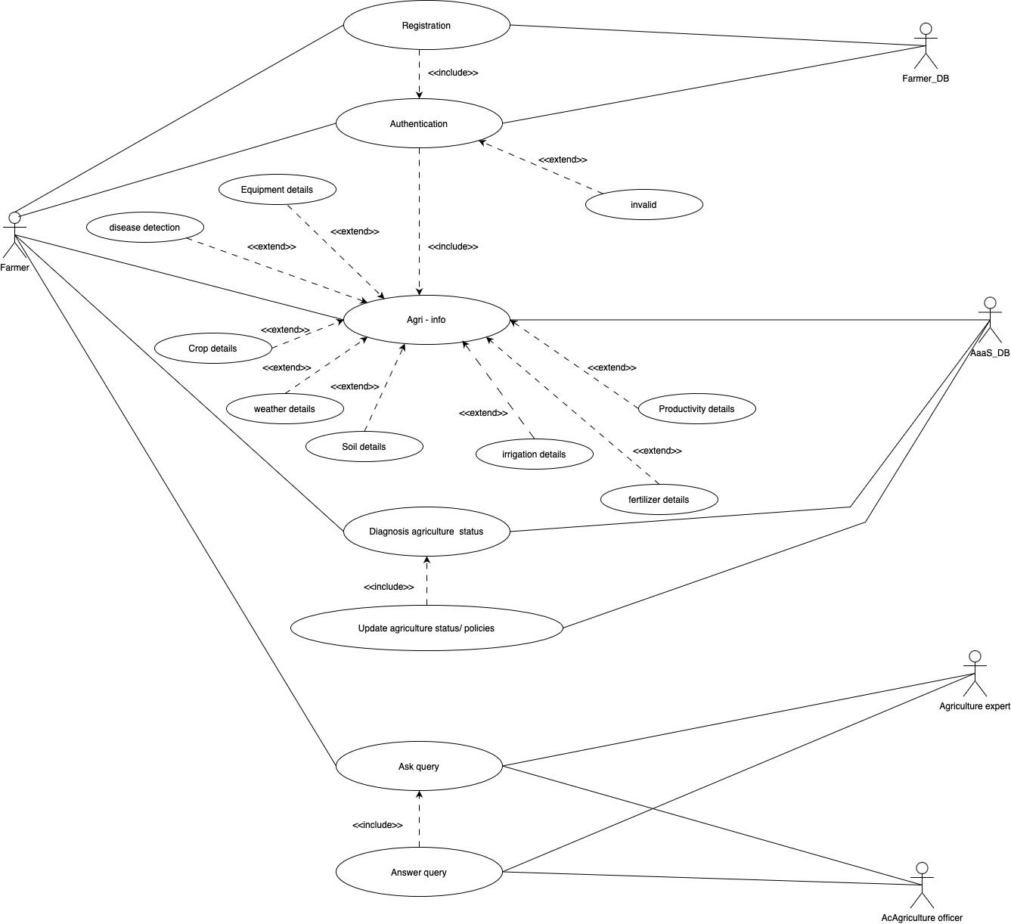

**Fig 3.1 (Use Cases)**

Fig 3.1 Represent the use cases, they are represented as ovals, while actors (users or external systems) are depicted as stick figures or other relevant symbols. The relationships between use cases and actors are illustrated through lines connecting them. The <<include>> notation is used to indicate that one use case includes the functionality of another use case. For example, in a banking system, the "Make Deposit" use case may include the "Verify Account" use case to ensure the user has a valid account before accepting the deposit. On the other hand, the <<extend>> notation is used to depict optional or alternative behaviors within a use case. It signifies that the extending use case may be invoked under certain conditions or based on specific triggers. These extended use cases provide additional functionality that is not always required. For instance, in an e-commerce system, the "Place Order" use case may be extended by the optional use case "Apply Discount Code" if the customer possesses a discount code. Use case diagrams help stakeholders gain a better understanding of the system's functionality, its boundaries, and the various actors involved. For a more comprehensive understanding, use case descriptions, activity diagrams, and sequence diagrams can be used to provide further clarification and detail on specific use cases and their interactions. A use case diagram is a graphical depiction of a user's possible interactions with a system. A use case diagram shows various use cases and different types of users. The notation <<include>> is used when a use case is depicted as using the functionality of another use case. The notation <<extend>> is used when the next connected use case is optional.

**FARMER:** In this System, Farmer can register as a user, diagnose agricultural status, can ask for a query and answer other queries. Farmer can view Agricultural Information and Fields Current Situation.

**FARMER DATABASE:** In this System, You can login into your account. Your basic information will be stored in database.

**ANALYTICS AS A SERVICE:** Analytics as services typically offer a variety of analytics tools and services, including data warehousing, data visualization, data mining, machine learning, and statistical analysis. The service is typically accessed through the cloud and is often provided on a subscription basis.

**AGRICULTURAL EXPERT:** Agricultural Expert Can view the new addition in the field and also post their answer for already asked queries

**AGRICULTURAL OFFICER:** Agricultural officer can also ask about queries and also post their answer for already asked queries and can also view Agricultural-info.

* 1. **Class (UML) Diagram:**

A class diagram is a type of Unified Modeling Language (UML) diagram that provides a static view of a system's structure by illustrating the classes, their attributes, methods, relationships, and constraints. It is one of the most widely used UML diagrams in software development and design. In a class diagram, classes are represented as boxes with three sections: Class Name: The name of the class is written in the top section of the box. Attributes: The attributes or properties of the class are listed in the middle section of the box. Each attribute typically includes its name and type. Methods: The methods or operations that the class can perform are listed in the bottom section of the box. Each method includes its name, parameters, and return type.

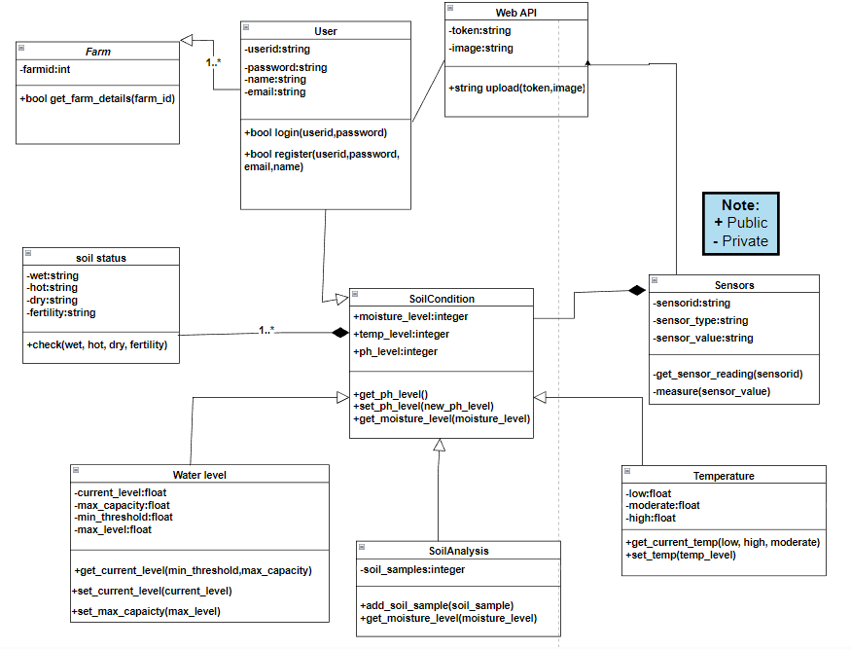

**Fig 3.2 (Class/ UML Diagram)**

Fig 3.2 Represents Class diagrams for A.I Based and controlled smart agricultural field; they are structural Unified Modelling Language (UML) diagrams that show the system in its static state. They're used to document, depict, and describe the various aspects of an object-oriented system, as well as to build executable functions and write programming code for it. In the context of the project "A. I Based and Controlled Agricultural Field," a class diagram would depict the different classes and objects that make up the system, as well as their interactions and dependencies. Some potential classes that could be included in the class diagram for this project consists of:

**Sensor**: This class would represent the sensors used to collect data about the agricultural environment, such as temperature, humidity, and video signals. It would have methods for collecting data and sending it to the cloud.

**Cloud**: This class would represent the cloud-based storage and processing system used to store and analyze the data collected by the sensors. It would have methods for receiving and storing data, as well as for analyzing the data and generating control actions.

**User**: This class would represent the users who access the system remotely to observe the data and generate control actions. It would have methods for connecting to the cloud and viewing the data, as well as for generating control actions.

**Control**: This class would represent the different control actions that can be generated by the system, such as watering plants, distributing pesticides, and managing waste.

**Agricultural Field**: This class would represent the agricultural field that is being monitored and controlled by the system. It would have attributes such as location, size, and type of crop. These classes would likely be related to each other in a number of ways.

For example, the Sensor class would likely have a relationship with the Cloud class, as the sensors send data to the cloud. Similarly, the User class would likely have a relationship with the Cloud class, as user’s access the data stored on the cloud.

The Control class would have a relationship with the Agricultural Field class, as the control actions are executed on the agricultural field. A class diagram would typically show these relationships and dependencies graphically, using lines and arrows to indicate the direction of the relationship and any constraints or multiplicities.

* 1. **Circuit Diagram:**

A circuit diagram, also known as an electrical schematic or wiring diagram, is a graphical representation of an electrical circuit. It uses symbols to illustrate the components of a circuit and their interconnections. Circuit diagrams are commonly used in electrical engineering, electronics, and related fields to communicate and document the design, construction, and troubleshooting of electrical systems. In a circuit diagram, various electrical components such as resistors, capacitors, inductors, transistors, diodes, and integrated circuits are represented by standardized symbols. These symbols provide a concise and universal way of representing each component, making it easier to understand and interpret the circuit.

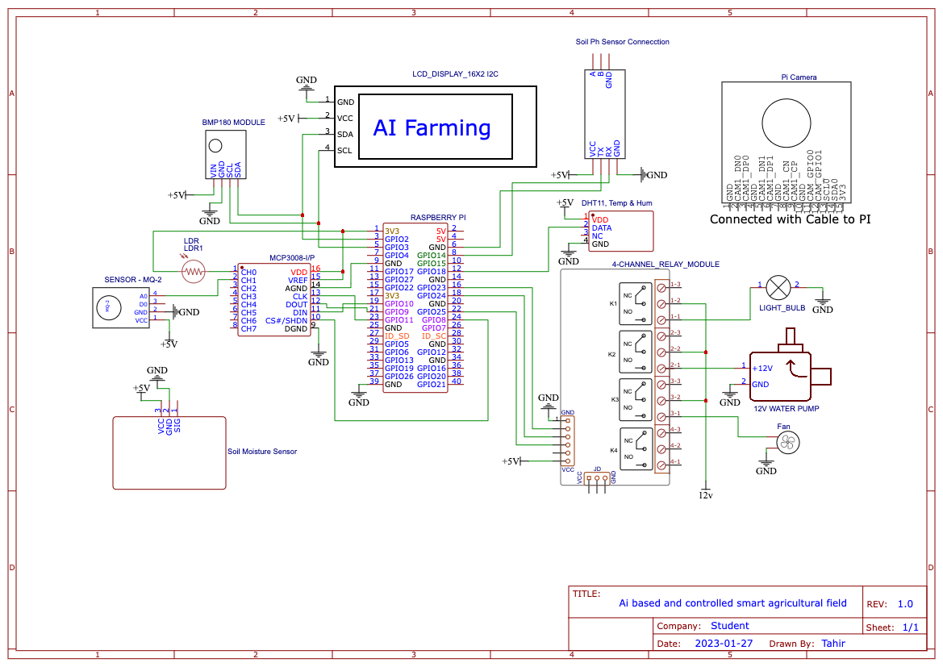

**Fig 3.3 (Circuit Diagram)**

Fig 3.3 Elaborates circuit diagram for an "AI-based and controlled smart agricultural field" using These components would be connected together using wires, and the Raspberry Pi would control the sensors and actuators using its GPIO pins, and the MCP3008 and relay module. The specific circuit diagram would depend on the specific components and their connections, but this should give you an idea of the components that would be involved in such a system.

The smart farming system would consist of several components working together to monitor and control the agricultural environment. The Raspberry Pi would serve as the main controller, running AI algorithms and facilitating communication with the various sensors and actuators. The system would incorporate an LDR sensor to measure the amount of light falling on the plants, providing valuable information about the lighting conditions in the field. Additionally, a soil moisture sensor would be utilized to measure the moisture content of the soil, offering insights into the water needs of the plants. To assess the environmental conditions, a DHT11 temperature and humidity sensor would measure the air temperature and humidity in the field. This data would contribute to making informed decisions regarding crop health and growth.

The system would feature an LCD display to showcase vital information such as sensor readings and control decisions, enabling farmers to monitor the system easily. Actuators would be controlled through the system, including a 12V fan used to regulate air flow in the field, promoting better circulation and temperature control. A water pump would also be employed to manage water flow to the plants, allowing for irrigation based on the readings from the soil moisture sensor. To facilitate control of the various actuators, four-channel relay modules would be integrated into the system. These modules enable the Raspberry Pi to control the fan, water pump, and other devices. For analog signal conversion, an MCP3008 Analog-to-Digital Converter would be utilized.

It would convert analog signals from the soil moisture sensor and other analog sensors into digital signals that can be read and processed by the Raspberry Pi. Additionally, the system would incorporate a BMP180 Barometric Pressure Sensor to measure atmospheric pressure in the field, providing valuable data for weather monitoring. Lastly, an MQ135 Gas sensor would be employed to measure air quality, ensuring a healthy environment for the crops. By utilizing these components, the smart farming system can effectively monitor and control various environmental factors, optimizing conditions for crop growth and maximizing agricultural productivity.

* 1. **Process flow Diagram:**

A process flow diagram (PFD) is a graphical representation that illustrates the sequence of steps or activities involved in a process or system. It provides a high-level overview of the flow of materials, information, or resources through different stages of a process. Process flow diagrams are widely used in various industries, including manufacturing, chemical engineering, and business process management. In a process flow diagram, the process is typically represented by boxes or rectangles, and the flow of materials or information is depicted by arrows connecting the boxes. Each box represents a specific task, operation, or stage of the process, and the arrows indicate the direction and order in which the activities are performed.

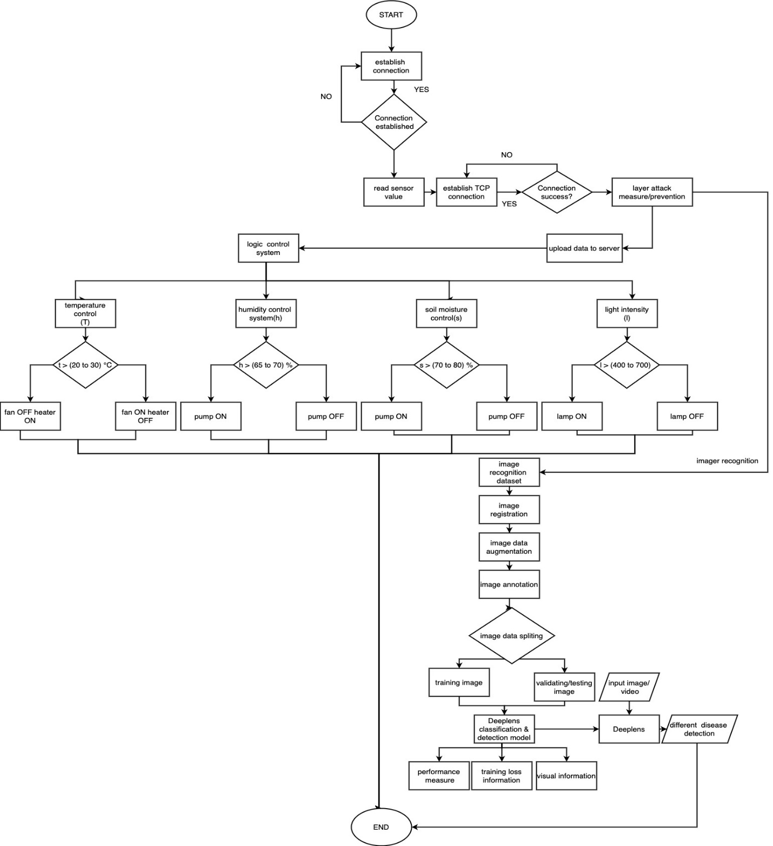

**Fig 3.4 (Process Flow Diagram)**

Fig 3.4 explains the process for remotely monitoring and controlling agricultural processes using sensors, cloud technology, and mobile or computer devices is process flow. The initial stage of the process involves using sensors to measure various environmental characteristics of agricultural areas, such as temperature, humidity, and video signals. This measured data is then sent over the cloud using a hardware device, allowing users to access and observe the data from anywhere in the world via a mobile phone or personal computer. Using this information, users can generate necessary control actions to regulate the agricultural farming processes, such as watering plants, distributing pesticides, managing waste, and controlling animals. This allows for efficient and convenient management of agricultural operations, even when the user is not physically present on the farm. A process flow diagram is a type of diagram that visually represents the steps and decisions involved in a process. In the context of the project "A.I Based and Controlled Agricultural Field," a process flow diagram would depict the different stages and actions that make up the system, as well as how they are connected and what decisions are made at each step.

A possible process flow diagram for this project could include the following steps: Data collection: Sensors installed in the agricultural field collect data about the environment, such as temperature, humidity, and video signals. Data transmission: The collected data is sent to the cloud-based storage and processing system. Data analysis: The data is analyzed to identify patterns and generate control actions. Control action generation: Based on the analysis, control actions are generated to regulate the agricultural farming processes like watering of the plants, pesticide distribution, waste management, animal control, etc. User access: Users access the system remotely using mobile phone or personal computer to observe the data and generate control actions. Control action execution: The control actions are executed on the agricultural field. Feedback: The system receives feedback from the agricultural field, and the process starts again from step one in the process flow diagram, each step would be represented as a box or shape, with arrows connecting them to show the flow of the process. Decision points, where the system must make a choice based on certain conditions would be represented as diamonds or other shapes.

Users access the system remotely using their mobile phones or personal computers, allowing them to observe the data collected from the agricultural field and generate control actions. The system facilitates this interaction through a user-friendly interface that provides real-time updates and visualizations of the field data. Once the users have analyzed the data and made decisions regarding the necessary control actions, the system initiates the execution of these actions on the agricultural field. This may involve activating actuators, such as water pumps, irrigation systems, or climate control devices, to implement the desired changes in the field environment. As the control actions are executed, the system continuously receives feedback from the agricultural field, providing information about the impact of the actions taken. This feedback loop is essential for monitoring the effectiveness of the control measures and making any necessary adjustments or refinements to optimize the agricultural processes. To illustrate the process flow, a diagram is used, where each step is represented as a box or shape. Arrows connect these shapes to show the flow of the process from one step to another. Decision points, where the system needs to make choices based on specific conditions, are represented as diamonds or other shapes to visually indicate these decision-making points. This iterative process ensures that the smart agricultural system operates in a closed loop, continuously monitoring, analyzing, and responding to the field conditions.

* 1. **Implementation:**

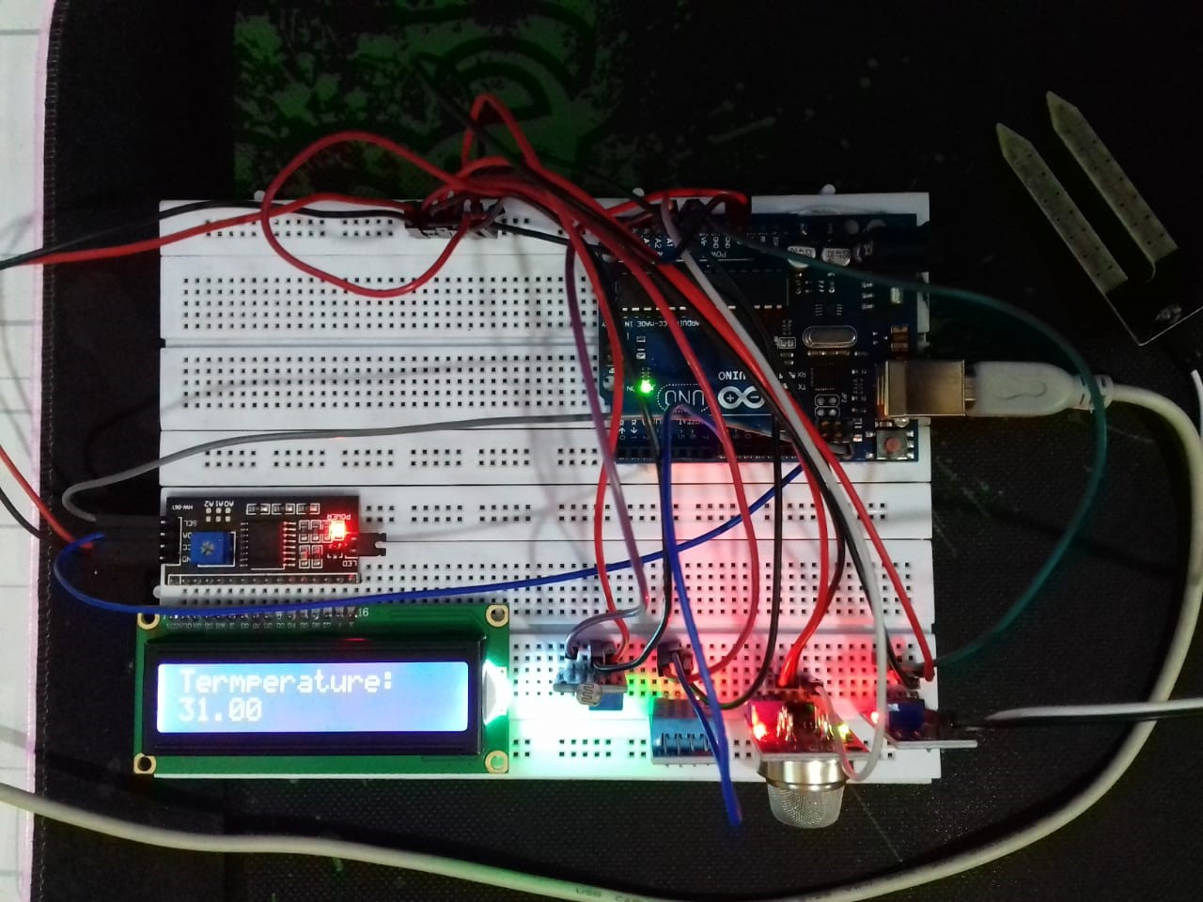

**Fig 3.5 (Circuit Demonstration)**

Fig 3.5 Demonstrate that the code below implements an A.I -based and controlled Smart Agriculture Monitoring System with sensors, as well as sending data to the cloud in real time to display an accurate result. We also used various libraries to refer to the code in different modules like LiquidCrystal_I2C.h, dht.h, Adafruit_BMP085.h

**Hardware Setup:** Deploy a network of sensors and actuators across the agricultural field. Sensors should include temperature and humidity sensors, soil pH sensors, and cameras for image detection. Actuators should include water sprinklers and pesticide dispensers. Connect the sensors and actuators to a central control unit, which serves as the brain of the system. The control unit should be capable of collecting data from sensors and sending commands to the actuators.

**Data Collection:** Configure the control unit to collect data from the sensors at regular intervals. This can be achieved by using appropriate protocols such as MQTT or HTTP to communicate with the sensors. Store the collected data in a database for further analysis and visualization. Use a database management system (e.g., MySQL, MongoDB) to store the data securely. Implement a communication module that transmits the collected data to a web server in real-time. This can be done using REST APIs or WebSocket protocols.

**Web-Based Visualization:** Develop a web application to visualize the live data collected from the agricultural field. Use HTML, CSS, and JavaScript frameworks such as React or Angular for front-end development. Establish a connection between the web application and the database to retrieve real-time data. Utilize server-side technologies such as Node.js or Django to handle data retrieval and serve it to the front-end. Design intuitive and interactive visualizations such as graphs, charts, and maps to display temperature, humidity, soil pH, and disease data in a user-friendly manner.

**Automated Water and Pesticide Dispensing:** Implement AI algorithms to analyze the collected data and determine the optimal water and pesticide requirements for the crops. Develop control logic that automatically triggers the water sprinklers and pesticide dispensers based on the analysis results. Integrate the control logic with the actuators in the field to enable automated water and pesticide provision to the plants.

**Manual Control Interface:** Create a user interface in the web application to allow manual control of water and pesticide dispensing. Provide options for users to adjust water quantity and schedule irrigation manually. Enable users to manually trigger pesticide dispensing when required.By implementing the above steps, you can create an AI-based smart agriculture system that collects real-time data on temperature, humidity, soil pH, and plant diseases. The system will transmit the data to a database and display it on a live website. Additionally, the system will automate the provision of water and pesticides to the plants based on AI analysis, while also allowing manual control for users. This integrated approach will enhance crop monitoring, optimize resource utilization, and enable efficient decision-making for sustainable agriculture.

# Chapter # 4

**Data Analysis**

**4.1 Artificial Intelligence Based Farming:**

AI-based farming, also known as smart farming or precision agriculture, refers to the application of artificial intelligence (AI) and other advanced technologies in the agricultural industry to optimize and automate farming operations. This approach aims to enhance crop yields, minimize resource wastage, and increase overall efficiency in farming practices. Here are some key areas where AI is being applied in farming: Data-driven decision making: AI algorithms can analyze vast amounts of data collected from various sources such as weather patterns, soil conditions, crop growth stages, and historical yield data. By processing this information, AI systems can provide farmers with valuable insights and recommendations for optimal decision making. For example, AI can suggest the best time for planting, irrigating, or applying fertilizers based on real-time data analysis. Crop and soil monitoring: AI-powered sensors, drones, and satellite imagery can be used to collect data about crop health, soil moisture levels, nutrient deficiencies, and pest infestations. This information is then processed by AI algorithms to detect patterns, identify potential issues, and provide early warnings. This enables farmers to take timely actions, such as targeted pesticide application or irrigation, to prevent crop damage and optimize resource usage. Robotic automation: AI and robotics are combined to automate labor-intensive tasks on the farm. For example, autonomous robots can be employed for seeding, planting, weeding, and harvesting crops. These robots use AI algorithms to navigate fields, identify plants, and perform precise actions. Robotic automation reduces the need for manual labor, improves efficiency, and reduces costs. Predictive analytics: AI algorithms can analyze historical data and environmental factors to predict future outcomes, such as crop yield, disease outbreaks, or market demand. This enables farmers to make informed decisions and plan their farming operations accordingly, minimizing risks and maximizing productivity. Resource optimization: AI can optimize the use of resources like water, fertilizers, and energy. By continuously monitoring environmental conditions and crop needs, AI systems can precisely control the amount and timing of resource application, reducing waste and environmental impact. Livestock monitoring: AI-based systems can monitor and analyze the behavior, health, and well-being of livestock. This includes tracking movement patterns, detecting signs of illness, optimizing feeding schedules, and managing breeding programs. AI-powered sensors and computer vision technologies enable real-time monitoring of livestock, providing farmers with valuable insights for better management. Overall, AI-based farming holds the potential to revolutionize agriculture by improving productivity, sustainability, and profitability. By leveraging advanced technologies and data-driven insights, farmers can optimize their operations and make informed decisions, leading to more efficient and sustainable food production.

**4.2 Image Processing on Plants:**

Image processing plays a crucial role in smart farming when it comes to plant monitoring and analysis. By using advanced image processing techniques and computer vision algorithms, farmers can gather valuable information about the health, growth, and quality of plants. Here are some key applications of image processing in smart farming: Plant health assessment: Image processing algorithms can analyze images of plants to assess their health conditions. By capturing images of crops in different spectral bands (visible, infrared, or multispectral), it is possible to detect indicators of stress, nutrient deficiencies, diseases, or pest infestations. These algorithms can identify specific patterns or color variations that indicate plant health issues, allowing farmers to take prompt action. Weed detection and management: Image processing can help identify and differentiate between crops and weeds. By analyzing images of fields, computer vision algorithms can detect the presence of weeds and provide information about their density and distribution. This enables farmers to target weed control measures more accurately, reducing the need for broad-spectrum herbicides and minimizing crop damage. Crop yield estimation: Image processing techniques can be used to estimate crop yields by analyzing images of plants throughout their growth stages. By measuring parameters such as plant density, leaf area, or fruit size, algorithms can make predictions about the final yield. This information can assist farmers in optimizing resource allocation, harvest planning, and market forecasting. Fruit grading and quality assessment: Image processing can be employed to assess the quality of fruits based on their size, shape, color, and external characteristics. By capturing images of harvested fruits, computer vision algorithms can classify and sort them according to predetermined quality standards. This enables farmers to automate the grading process, ensuring consistent product quality and optimizing market value. Plant phenotyping: Image processing facilitates the measurement and analysis of various plant traits, known as plant phenotyping. This includes features such as plant height, leaf area, canopy structure, or root morphology. By capturing high-resolution images of plants, computer vision algorithms can extract quantitative data, providing valuable insights for breeding programs, crop improvement, and precision agriculture practices. Disease and pest detection: Image processing techniques can assist in the early detection and identification of diseases and pest infestations. By analyzing images of plants, algorithms can identify visual symptoms or patterns associated with specific diseases or pests. This helps farmers take timely actions such as targeted treatment or quarantine measures, preventing the spread of pathogens and minimizing crop losses.

**4.3 Image Processing Algorithm:**

**a. Image segmentation:**

Image segmentation is a crucial step in plant disease detection, as it helps separate the regions of interest from the background. This process involves dividing an image into multiple segments, each representing a specific feature or area. In the context of plant disease detection, image segmentation can be used to isolate plant leaves from the background or to separate healthy and diseased areas of a leaf. Common techniques for image segmentation include thresholding, region growing, and edge detection.

**b. Feature extraction:**

Feature extraction is the process of extracting meaningful and representative features from input images that can be used to train a machine learning model for classification. These features should be able to distinguish between healthy and diseased plants effectively. Some popular feature extraction techniques include:

Histogram of Oriented Gradients (HOG): HOG captures the distribution of edge orientations in an image, which can be useful for identifying patterns and textures in plant leaves.

Local Binary Patterns (LBP): LBP is a texture descriptor that captures local patterns in an image, which can help identify disease-related changes in plant leaves.

Convolutional Neural Networks (CNNs): CNNs are deep learning-based models that can automatically learn hierarchical features from input images, making them highly effective for plant disease detection.

**c. Classification:**

Classification is the process of using a trained machine learning model to categorize new images as either healthy or diseased. The model is trained using the features extracted from the input images. Common classifiers used in plant disease detection include:

* Support Vector Machines (SVMs): SVMs are a type of supervised learning model that can effectively classify data into two or more classes.
* Decision Trees: Decision trees are a type of classifier that uses a tree-like structure to make decisions based on input features.
* Random Forests: Random forests are an ensemble learning method that combines multiple decision trees to improve classification accuracy and prevent overfitting.

**d. Preprocessing:**

Preprocessing is an essential step in image processing for plant disease detection, as it helps improve the quality of input images before applying the main algorithms. Common preprocessing techniques include:

* Image resizing: Adjusting the size of the input images to a consistent dimension, which can help improve the performance of the machine learning model.
* Normalization: Scaling the pixel values of the input images to a specific range, which can help improve the convergence of the machine learning model.
* Color correction: Adjusting the color balance of the input images to ensure consistent color representation across the dataset.
* Thresholding: Applying a threshold to the input images to separate the foreground (plant leaves) from the background.

**e. Data augmentation:**

Data augmentation is a technique used to increase the size of the dataset and improve the robustness of the machine learning model. By applying various transformations to the input images, such as random cropping, flipping, and rotation, additional training samples can be generated. This helps the model learn more diverse features and reduces the risk of overfitting, ultimately leading to better performance in plant disease detection.

**f. Dataset and Network for Disease Diagnosis Training:**

The images presented in this report were obtained from the Plant Village dataset, available at https://www.kaggle.com/datasets/arjuntejaswi/plant-village. This dataset is comprised of a set of 20,639 leaf images, which have been classified into 15 labels based on whether they are healthy or diseased, and the type of disease present . To train our machine learning model for plant disease diagnosis, we split the dataset into three subsets - training, validation, and testing - using a 70:30 ratio. We chose a network architecture that primarily utilized convolutional blocks without any complex layers such as residual connections, to facilitate easier interpretation of the intermediate layers.

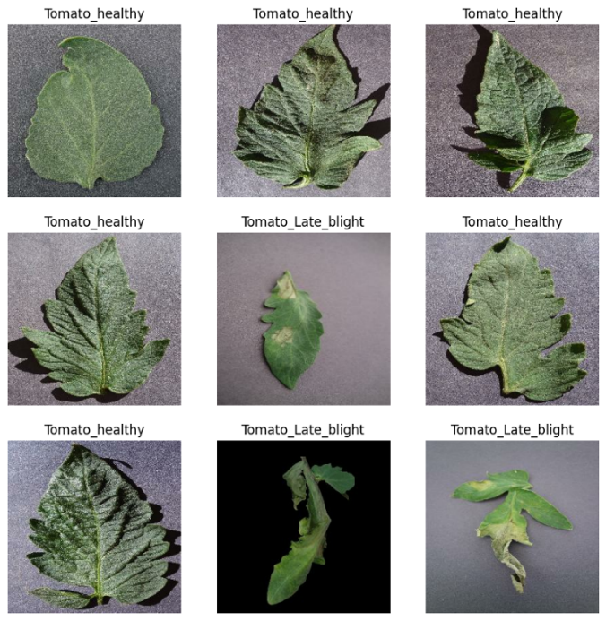

**Fig 4.1 (Plant’s Types of diseases)**

Fig 4.1 Represents For the test phase of the study, we used the network weights corresponding to the lowest validation loss (50th epoch) to evaluate the accuracy and loss values of the training, validation, and test datasets. The resulting confusion matrix indicated that there was no significant imbalance in the accuracy of any class, as shown in

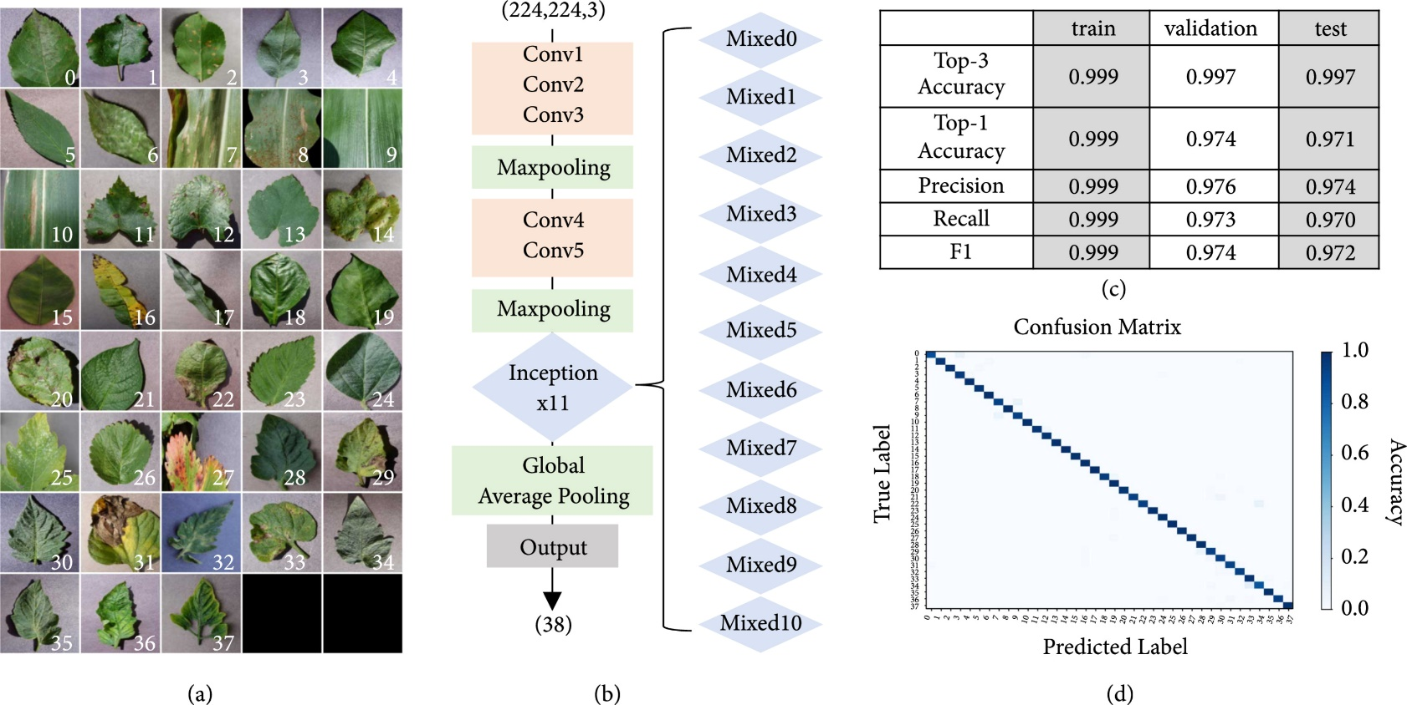

**Fig 4.2 (Confusion Matrix)**

Fig 4.2 Demonstrate the confusion matrix is a table used to evaluate the performance of a machine learning algorithm in classification problems. It shows the number of true positives, false positives, true negatives, and false negatives for each class.

In the context of plant disease detection, a confusion matrix can be used to assess how well a machine learning model is able to classify images of plants as healthy or diseased. For example, imagine a dataset of plant images labeled as either healthy or infected with a specific disease. A machine learning algorithm can be trained on this data to predict whether a new image of a plant is healthy or diseased. After training the algorithm, its performance can be evaluated using a confusion matrix. The rows of the matrix would represent the actual labels (healthy or diseased), while the columns would represent the predicted labels. The true positives would be the number of diseased plants correctly identified as such, false positives would be healthy plants incorrectly identified as diseased, true negatives would be healthy plants correctly identified as such, and false negatives would be diseased plants incorrectly identified as healthy. By analyzing the values in the confusion matrix, we can calculate metrics such as precision, recall, and F1 score to evaluate how well the model is performing at detecting plant diseases. A high precision value indicates that the model is correctly identifying diseased plants with low false positive rate, while a high recall value indicates that the model is correctly identifying most of the diseased plants with low false negative rate.

**g.** **Plotting the Inference Data:**

The 3rd figure in this report showcases the visualization of hidden layer outputs for each layer, utilizing an input image of tomato early blight as a representative example. The intermediate outputs generated by our trained model are summarized and analyzed in detail. Our analysis revealed that some of the intermediate outputs from the shallow layers exhibited significant activation.

However, due to the nature of the global average pooling layer, which converts images to feature vectors that lack spatial information, it becomes arduous to comprehend how the extracted features contribute to the classification of the input image into the correct disease class. Consequently, discerning whether the extracted features positively impact the classification of the input image or are instead used to deny other possibilities can be challenging. These limitations illustrate that relying solely on intermediate outputs is insufficient to obtain a complete understanding of what the CNN has learned about tomato disease classification.

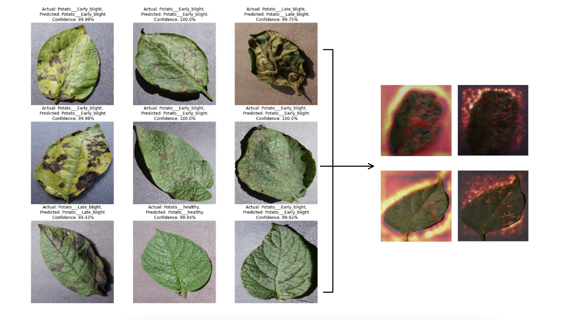

**Fig 4.3 (diagnose plant diseases)**  
Finally, we utilized this set of weights to interpret how the neural network was able to learn to diagnose plant diseases with a relatively high degree of accuracy and the Model shows accuracy

Total params: 183,747

Trainable params: 183,747

Non-trainable params: 0

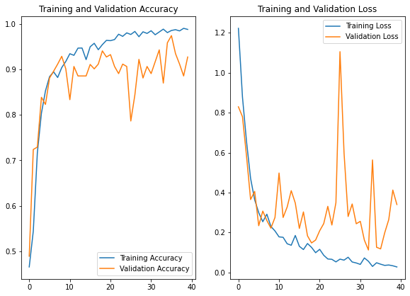

**Fig 4.4 (Data Sets)**

Fig 4.4 Involved, it is important to acknowledge that in a dataset consisting of 15 class labels, random guessing would only yield a minimal overall accuracy on average. Throughout our various experimental configurations, which encompass three distinct visual representations of the image data, the overall accuracy achieved on the Plant Village dataset ranged from 95.03%. This demonstrates the considerable potential of deep learning approaches for addressing similar prediction challenges. The mean precision, mean recall, and overall accuracy were consistently observed across all experimental configurations. Each configuration was executed for a total of 50 epochs, and convergence was almost invariably achieved following the initial reduction in the learning rate.

**4.4 Data from Sensors:**

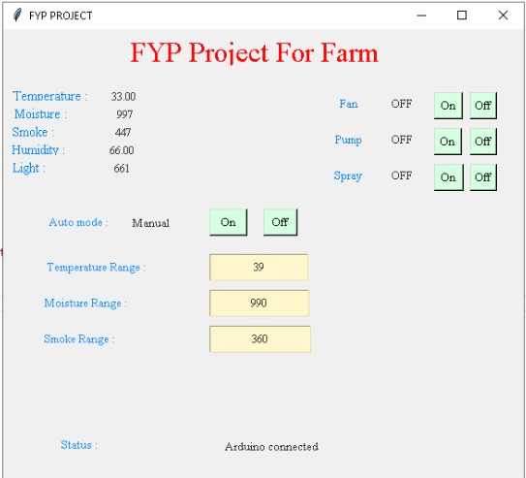

**Fig 4.5 (Project Interface)**

Fig 4.5 Represent the Graphical user interface for project A.I based and controlled smart agricultural field in which Values are displaying live from the field with the help of IoT sensors. An AI-based and controlled smart agricultural system can greatly benefit from IoT sensors and software to gather and display live field data. Here's an overview of how such a system might work: IoT Sensors: Deploy various IoT sensors in the agricultural field to collect data on environmental conditions, soil moisture, temperature, humidity, light intensity, and other relevant parameters. These sensors can be placed strategically throughout the field to ensure comprehensive data collection. Data Transmission: The IoT sensors will transmit the collected data wirelessly to a central hub or gateway located on the farm. This hub acts as a bridge between the sensors and the software system. Data Processing and AI: The collected data is sent to an AI-powered software system that performs data processing and analysis. The AI algorithms can leverage machine learning techniques to identify patterns, predict crop growth, detect anomalies, and provide actionable insights for efficient decision-making. Real-Time Monitoring: The software system receives the processed data from the AI algorithms and displays it in real-time. This information can be accessed through a web-based dashboard or a mobile application, allowing farmers to monitor the field conditions remotely. Alert and Notification System: The AI algorithms can be programmed to detect critical events or deviations from optimal conditions, such as low soil moisture levels or pest infestations. In such cases, the system can send real-time alerts and notifications to farmers or agronomists, enabling them to take immediate action to address the issue. Historical Data Analysis: The software system can store and analyze historical data, allowing farmers to gain insights into long-term trends, make informed decisions, and optimize their farming practices. This analysis can help identify the best planting periods, optimize irrigation schedules, and improve crop yields. Integration with Smart Devices: The AI-based agricultural system can integrate with other smart devices such as automated irrigation systems, robotic equipment, or weather stations. This integration enables seamless control and automation of farming processes based on real-time field data. By combining IoT sensors, AI algorithms, and software systems, farmers can gain valuable insights into their agricultural operations, enhance productivity, and make data-driven decisions for optimal crop management.

# Chapter # 5

**Conclusion and Future Work**

1. **Conclusion:**

Smart farming or smart agriculture is the term for the application of A.I technologies in farming. In smart farming automation, A.I collects data using sensors/RFIDs, analyses the data using controllers, and completes the automation process with actuators. Traditional farming methods and a lack of contemporary technologies are preventing Pakistan from reaping the full benefits of the agriculture sector. Furthermore, as a result of increasing demand and price increases, major food staples such as potatoes, onions, chills, and tomatoes have gained economic importance in recent years. For these reasons, Pakistan imports agricultural products from other countries. Swat and Dir districts in Pakistan's Khyber Pakhtunkhwa Province's Malaccan Division are among the country's top ten onion-producing districts. On the other hand, farmers face a difficulty known as onion bolting or flowering, which is caused by changes in the onion crop's environmental conditions. Cold temperatures and an extended photoperiod increase onion flowering and bolting. To prevent onion bolting, technology-based smart farming and an effective monitoring system are required to overcome the aforementioned challenge in onion growing. The strategy should help the farmer detect bolting early and take preventative measures to avoid bolting, leading in increased onion yield. As a result, the SFMS was developed to avoid onion bolting and increase onion crop yield.

1. **Future Work:**

This study might be developed to incorporate an SFMS prediction module, a second module for tweaking and modifying the greenhouse, and a third module for employing the SFMS in poultry farms. The agricultural sector is vital to the economy of the region. It is transitioning to a market economy, just like the rest of the economy, with considerable changes in social, legal, structural, production, and supply structures. As a result of these developments, most countries' agricultural production has fallen, affecting the region's national seed supply industry. Food insecurity has been a problem in the region, with some countries requiring food aid for internally displaced persons and refugees. Due to the relatively low demographic pressure projected for the future, the presence of some favorable types of climates, and other positive factors, including a very large formal seed supply sector, it should be possible to overcome problems of food insecurity in the region as a whole, and even to use this region to provide food to other food-deficient regions. As a result, in order to attain these objectives, opportunities must be created the device's results reveal that it is capable of acquiring, processing, and assessing intermittent data from sensors that are delivered to the central node for use by the farmers. In addition, the graphs show that soilless agriculture has a promising future in Pakistani agriculture. More work on the shield casing of nodes is necessary in adverse weather conditions. Renewable energy, a battery, or any other continuous power source must all be considered. Depending on the situation, auxiliary or replaceable sensors can be attached to the device. The device is tested with water and a small area of filthy crop. More research is needed in the areas of water and soil variation in different places of Pakistan. More research will be carried out in order to create a mobile and desktop application for monitoring and controlling the device. The economic viability of establishing this type of agriculture, as well as the equipment, must also be considered. Combining analytics tools that analyses data and act on it has the potential to reduce the requirement for human interaction even more. The device is relatively easy to use for end consumers, and it may be utilized in both small and large-scale farming.

# Chapter # 6

**Bibliography**

## [1]. [Shounak Chakraborty](https://onlinelibrary.wiley.com/action/doSearch?ContribAuthorRaw=Chakraborty%2C+Shounak), [Nikumani Choudhury](https://onlinelibrary.wiley.com/action/doSearch?ContribAuthorRaw=Choudhury%2C+Nikumani). “AI-Based Smart Agriculture Monitoring Using Ground-Based and Remotely Sensed Images”, Agricultural Sciences, Sustainability Science, Issue 16 march 2022

[2]. [Achim Walter](https://pubmed.ncbi.nlm.nih.gov/?term=Walter%20A%5BAuthor%5D), [Robert Finger](https://pubmed.ncbi.nlm.nih.gov/?term=Finger%20R%5BAuthor%5D) [Robert Huber](https://pubmed.ncbi.nlm.nih.gov/?term=Huber%20R%5BAuthor%5D), & [Nina Buchmann](https://pubmed.ncbi.nlm.nih.gov/?term=Buchmann%20N%5BAuthor%5D)”Smart farming is key to developing sustainable agriculture - Agricultural Sciences” Sustainability Science Published online, Issue 2017 Jun 13

[3]. Dieisson Pivoto, Paulo Dabdab “Scientific development of smart farming technologies and their application in Brazil” Information Processing in Agriculture. Issue, Volume 5, Issue 1, March 2018,

[4]. Anastasios lytos,thomaslagkas “inclination a muddled logical field” Smart Agricultural FieldIssue: 2021 April 18.

[5]. [Chartres](https://agricultureandfoodsecurity.biomedcentral.com/articles/10.1186/2048-7010-3-11#auth-Colin_J-Chartres),  [Jerry l Hatfield](https://agricultureandfoodsecurity.biomedcentral.com/articles/10.1186/2048-7010-3-11#auth-Jerry_L-Hatfield),  [Kevin henry](https://agricultureandfoodsecurity.biomedcentral.com/articles/10.1186/2048-7010-3-11#auth-Kevin-Henry), [Jan w Hopmans](https://agricultureandfoodsecurity.biomedcentral.com/articles/10.1186/2048-7010-3-11#auth-Jan_W-Hopmans), [William R Horwath](https://agricultureandfoodsecurity.biomedcentral.com/articles/10.1186/2048-7010-3-11#auth-William_R-Horwath) & [Bryan m Jenkin](https://agricultureandfoodsecurity.biomedcentral.com/articles/10.1186/2048-7010-3-11#auth-Bryan_M-Jenkins) “Environment shrewd farming (CSA) ” Smart Farming, Issue: 2020 Nov.

[6]. Yuanyuan Zhou, Qing Xia, Zichen Zhang, Mengqi Quan & Haoran Li “Artificial intelligence and machine learning for the green development”, manufacturing industry in the IoT platform, Received 14 Jul 2021, Accepted 16 Nov 2021, Published online: 06 Dec 2021

[7]. Manickavasagan, g. Sathya, D.s. Jayas, “comparison of illuminations to identify wheat classes using monochrome images”, science direct -computers and electronics in agriculture 6 3, pp 237–244. 978-1-4673-9584-7/16/$31.00 2016.

[8]. Mengqi Quan, “programmer, water and jobs, the United Nations world water development report, united world water develop.” United Nations educ., sci. cultural org, Issue 2016.

[9]. [Aine Regan](https://www.tandfonline.com/author/Regan%2C+%C3%81ine) “Smart farming’ in Ireland: A risk perception study with key governance actors” Volumes 90–91, December 2019,

[10]. Kun Mean Hou, “New Technologies for Smart Farming 4.0: Research Challenges and Opportunities” Issue 15 August 2019.

[11]. Mohamed abdel aziz, belal belalsameh, & abd-elmabod mohammed “Smart Agricultural farming “computer science:722-25, pp.722-725, Issue 19 March 2020

[12] Diego Durante Mühla, & Letícia de Oliveiraba “bibliometric and thematic approach to agriculture”, Issue 2022 May 6.

[13]. Corinne bernstein, “smart farming agriculture” Issue 20 March 2021

[14]. lisa dilling. “prioritizing climate-smart agriculture: an organizational” and temporal review  
, editor-in-chiefconferences on internet of things, and cyber, physical and social computing’,978-0-7695-4580-6/11 © 2011,Issue 20 December 2020.

[15]. Michele Kremer, Leandro da silva Nascimento 2, Cristian Rogério Foguesatto 1 , leonardo b. furstenau 2 , kadígia faccin 1 ,paulo antônio zawislak 2 , bruce mellado 3 , jude dzevela kong 4 and nicola luigi bragazzagriculture, “the scientific evolution of digital agriculture: challenges and application of the lot technology in smart farming”, Issue 26 Nov ./“

[16]. Qing Xia, Zichen Zhang& Mengqi Quan “smart farming: A.I based smart sensor agriculture stick for live temperature and humidity monitoring design of efficient hydroponic nutrient solution control system using soft computing-based solution grading”, Issue 27 Nov.

[17] ronnie Vernooy & Claudia Bouroncle **“**climate-smart agriculture: in need of a theory of scaling “, Issue 16 July @ 2021.

[18]. Ritika srivastava1, Vandana sharma2, Vishal jaiswal3 & Sumit raj4” a research paper on smart agriculture using A.I “, Issue 2020 April 21.

[19]. Kerri L Steenwerth, Amanda K Hodson, Arnold J Bloom, Michael R Carter, Andrea Cattaneo, Colin J Chartres, Jerry L Hatfield, Kevin Henry, Jan W Hopmans, William R Horwath, Bryan M Jenkins, Ermias Kebreab, Rik Leemans, Leslie Lipper, Mark N Lubell, Siwa Msangi, Ravi Prabhu, Matthew P Reynolds, Samuel Sandoval Solis, William M Sischo, Michael Springborn, Pablo Tittonell, Stephen M Wheeler, Sonja J Vermeulen, & Louise E Jackson “climate-smart agriculture global research agenda: scientific basis for action”, Issue 26 August 2014.

[20]. Ermias Kebreab & Rik Leemans, “smart farming: the new agricultural benchmark technology”, volume 02, no 04, 0, Issue 8 October 2015.